

**Government of the People’s Republic of Bangladesh Ministry of Local Government, Rural Development and Co-operatives**

**(Local Government Division)**

**Environmental and Social Screening Report On**

**Household Rainwater Harvesting System at Teknaf Upazila, Cox’s Bazar**

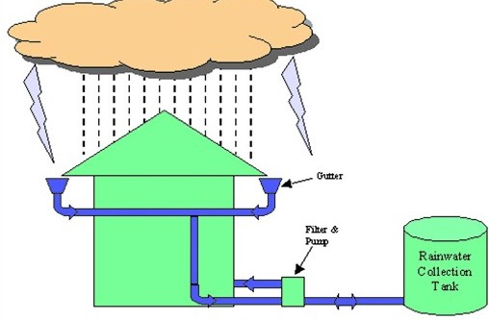

**Location: Baharchara, Sadar and St. Martain’s Island Unions of Teknaf Upazila, Dist.: Cox’s Bazar**

**Type-C (With New Catchment)**

**Sub-project (WD): EMCRP/AF/WD-27:110 Nos. (Vol-03]**

**Emergency Multi-Sector Rohingya Crisis Response Project (GoB-WB)**



Department of Public Health Engineering (DPHE)

**Abbreviation and Acronyms:**

|  |  |
| --- | --- |
| AF | Additional Finance |
| BBS | Bangladesh Bureau of Statistics |
| BD | Bangladesh |
| BMD | Bangladesh Meteorological Department |
| CoC | Code of Conduct |
| CI | Corrugated Iron |
| DC | Deputy Commissioner |
| DPHE | Department of Public Health Engineering |
| Dia. | Diameter |
| DRP | Displaced Rohingya Population |
| EE | Executive Engineer |
| EMCRP | Emergency Multi-sector Rohingya Crisis Response Project |
| ERP | Emergency Response Plan |
| E&S | Environmental & Social |
| ESMF | Environmental & Social Management Framework |
| ESMP | Environmental and Social Management Plan |
| FGD | Focal Group Discursion |
| GBV | Gender-Based Violence |
| GoB | Government of The People’s Republic of Bangladesh |
| GRC | Grievance Redress Committee |
| GRM | Grievance Redress Mechanism |
| HC | Host Community |
| HH | Household |
| HBB | Herringbone Bond |
| HDPE | High Density Polyethylene |
| IEF | Important Environmental Feature |
| ISCG | Inter Sector Coordination Group |
| IUCN | International Union for Conservation of Nature |
| LGED | Local Government Engineering Department |
| LGI | Local Government Institution |
| MHPSS | Mental Health and Psychological Support |
| NGO | Non-Government Organization |
| OHS | Occupational Health and Safety |
| O & M | Operation and Maintenance |
| PCC | Participatory Community Consultations |
| PM | Particulate Matter |
| PMU | Project Management Unit |
| PPE | Personal Protective Equipment |
| RCC | Reinforcement Cement Concrete |
| ROW | Right of Way | |
| RWH | Rainwater Harvesting | |
| RWHS | Rainwater Harvesting System | |
| SAE | Sub–Assistant Engineer | |
| SASA | Evidence-based community mobilization approach to prevent violence against women | |
| TDS | Total Dissolved Solids | |
| TSS | Total Suspended Solids | |
| UNFPA | United Nations Fund for Population Activities | |
| UNHCR | United Nations High Commissioner for Refugees | |
| UP | Union Parishad | |
| uPVC | Un plasticized Polyvinyl Chloride | |
| WASH | Water, Sanitation and Hygiene | |
| WB | World Bank | |
| WATSAN | Water and Sanitation | |

**EMCRP (DPHE part)**

**Environmental and Social Screening Form**

**Sub-Project Description Form**

**Introduction:**

Under additional financing (AF) of Emergency Multi Sector Rohingya Crisis Response Project (EMCRP), under work package AF/WD–27 DPHE has planned for the installation of Household Rainwater Harvesting system in Teknaf Upazila of Cox’s Bazar District.

The area of Teknaf Upazila is around 388.66 sq. km. located in between 20°23' and 21°09' North latitudes and in between 91°505 and 92°23' East longitudes. It is bounded by Ukhiya upazila on the north, The Bay of Bengal on the south, The Arakan State of Myanmar and the Naf River on the east and the Bay of Bengal on the west. Teknaf upazila, located on the south east extremity of Bangladesh, is 86 km on the south of Cox's Bazar Town. As of the [2011 Bangladesh census](https://en.wikipedia.org/wiki/2011_Bangladesh_census), the population of Cox’s Bazar district was 3.3 and Teknaf Upazila had around 23,6,75 households that contained a population of 2,64,389 (male 1,33,106 and female 1,31,283) and in addition to this around 1,58,266 nos. of displaced Rohingya people (DRP) also live in different camps of this Upazila (ISCG May 2024). Most of the underground of this Upazila is full of heavy thick layer of stone, which is rarely possible to drill and go down. There are few pocket layers/acquirers with very limited quantity of water and in most of the areas, there is no secured boreholes. So that, the Host community has been suffering from acute water scarcity.

As per demand of the targeted host community of Teknaf area, DPHE has planned to install 200 Rainwater Harvesting systems in different Unions under Teknaf Upazila aiming to mitigate their safe water scarcity by capturing rainwater and storing in the LLDPE Water Tank with necessary materials for capturing, collection and delivery of rainwater. Under EMCRP_AF/WD-27 sub-project there are three (Type-A, B & C) types of RWH systems planned and designed based on the catchment situation of household’s existing catchment infrastructural conditions. As per demand of the host community, DPHE has planned & designed to install Type ‘A’ for 70 Households having existing catchment/roof top area made of Tin, other infrastructures are Mud/Tin/Straw/Bamboo etc. which will provide required capture area for collection of rainwater; Type-B is designed for 20 Households having existing catchment /roof top made with damaged Tin and require to renovation/replacement and other infrastructure-Mud/Tin/Straw/Bamboo) and Type-“C” is designed for 110 hard-core Households people having existing rooftops made of polythene/ Straw/Bamboo and other infrastructure are Mud/Straw/Bamboo etc. which require installation of New Catchment for harvesting rainwater.

Based on scarcity of drinking water and demand of the host community, DPHE has planned to install around 110 nos. RWH system Type-C in three Unions (Sadar Union-16, Baharchara-73 & St. Martin’s Island -21 Nos) of Teknaf Upazila

This E&S screening report is prepared for the installation of proposed 110 Nos of RWH system ‘Type-C’ for the targeted host community of the said Unions of Teknaf Upazila, Cox’s Bazar District under contract package No. AF/WD–27 will be prepared as Vol-03.

**Name of Sub-project:**

Installation of Household Rainwater Harvesting systems in Host Community under scheme AF/WD-27 at Teknaf Upazila, Cox’s Bazar District.

**Implementing Agency/Agencies:** Department of Public Health Engineering (DPHE)

**The estimated total cost of 200 Rainwater Harvesting system under subject project Work Package:** BDT 2, 59 17, 441.22 (Around BDT 129,587.00 on an average for each)

**Estimated construction Period /duration:** 09 (Nine months)

**O & M and Estimated life time of the Sub-project:**

The individual household will be responsible for Operation and Maintenance. During the project (EMCRP) period operation and maintenance will be borne by the Contractor and local DPHE. After that the beneficiary will be the responsible for operation & maintenance of the RWHS. The expected lifetime of each RWHS scheme is around 10 (ten) years.

**District:** Cox’s Bazar

**Sub-District (Upazila):** Teknaf Upazila, Cox’s Bazar.

**Name of Union:** Sadar, Baharchara and St. Martin Island Unions of Teknaf Upazila.

**Name of Community/Local Area**: Host community of different unions under Teknaf Upazila.

**Description of proposed sub-project activities (incl. type of activities, footprint area, natural resources required, etc.):**

**In the proposed Household Rainwater Harvesting system (Type-C)** inTeknaf Upazila the following interventions would be taken place:

* Installation of 110 nos. RWH system under Type -C (New Catchment)
* Proposed area for type C around 27 sqm
* Fabrication of Flat Bar Hanger 600mmX25mmX2mm @2m
* Build Catchment area with CI/ Industrial Sheet near the house
* Construction of a platform upon which the LLDPE water tank will be placed
* 01 no. of LLDPE Water Tank capacity of 5000 Liter
* 100 mm X 50mm uPVC reducer, Elbow, Union, uPVC net etc.
* Setting of 38mm dia. GI Pipe
* Fixing of 38mm dia. Inlet and outlet uPVC pipe
* Setting of collection Tap from the catchment to the LLDPE water tank
* Fixing of Soaking pit/Drain
* CC block
* Fixing of 50mm uPVC Ball Valve
* Environmental Mitigation Works
* Operation & Maintenance work
* Fixing of Rrainwater Harvesting Filtration unit: Inside volume capacity of the proposed filter will be of 6 liters having 2 filters: (1) primary filter whose mesh size will be 100 and (2) the secondary filer will be of 5 microns where flow rate will be around 5 liters/second with 2-meters head having inlet Dia is 1.5 inches.

**Estimated footprint / land area for this sub-project:**

Under ‘Type-C’ Rainwater Harvesting System, the existing rooftop structure of the Household’s shall not be considered proper structure (such Mud/Tin/Straw/Bamboo etc.) for Rain Water Harvesting system. Around 21 sqm land will be required for making the structure with catchment (CI/ Industrial Sheet) area (9mX3m) of 27 sqm, 2 sqm for basin area and around 4 sqm (Dia 2.125m) platform for placing a 5000-liter LLDPE water tank as a reservoir for storing water from the catchment during rainfall. Influence area for each unit of RWH system ‘Type-C’ (as per layout diagram) is around 27 square meters. Around 5-6 people will use each water RWH system.

**Brief description of sub-project site: (e.g., present land use, Important Environmental Features (IEFs) near site, etc.:**

In the proposed locations of Sadar, Baharchara and St. Martin’s Island unions of Teknaf Upazila the host communities are of different religions and ethnicity. Most of the household pattern of the scheme area were found densely populated while some areas are with scattered.

Local DPHE, PMU E&S team representatives visited the proposed locations and five (05) consultation meetings were conducted (Total participants - 124, M-99, F-25, disable 0) with UP Chairman, councilors, community and Local Elite personals on feasibility and potentiality of the proposed RWHS scheme over there. After conducting the consultation meeting, discussion, site visit and analysis of the secondary information it has been revealed that most of the underground of this Upazila is full of heavy thick layer of stone, which is rarely possible to drill and go down. There are few pocket layers/acquirers with very limited quantity of water and in most of the areas, there is no secured boreholes. So that, the Host community has been suffering from acute water scarcity. The local people also opined that most of the people meet up their daily requirement of drinking water from shallow hand tube-wells just 20 to 30 feet below the ground which produce bad smell and excessive iron and, in some areas, water is salty and during dry season their hand tube-well become inactive. They also shared their experience of having water borne diseases. From the discussion it seemed to us that the water they collect might be contaminated that directly percolated during rainy season but when rains off they suffer from acute scarcity even they cannot bath for a weak. Some people collect safe water from the long distant sources. Based on the above circumstances, these areas are quite feasible and potential for Rainwater Harvesting scheme for safe water supply through which hard-core people of the proposed areas will be benefitted from ‘Type-C’ rainwater harvesting system schemes.

From discussion the individual HH of Baharchara, Sadar and St. Martin’s Island union of Teknaf Upazila agreed to provide around 21 sq. meter own land space from their household premise for installing a RWH system ‘Type-C’ (Flat Bar Hanger with a catchment area made of CI/Industrial Sheet and a platform for placing a 5000 liters LLDPE water tank as reservoir and setting of basins). The E&S Safeguard team adopt verbal mandate of the owner for implementing the schemes. To establish the scheme no significant negative impact was found in the said unions of the targeted area.

**Major institutions, infrastructures, Forest land existence:**

At the proposed areas of Rainwater Harvesting system (RWH) scheme there were some religious, educational institutions and business centers found like Mosques, Madrasha, High schools, Govt. Primary Schools, Union Health centers, Community clinic, Orphanage, Collage, Mondir, local bazar, fish call center, fishing ghut, port/Bondor, grocery shop etc. Apart from these, the Sea beaches, off-shore areas with Jhau bon (forest) and some natural forest lands were found far away from the sites but their impact is low. Other than these the marine drive, pucca roads, bridge, culvert, herringbone bond road (12-15 ft. width) and electric line run very close to the proposed sub-project areas. There was no any important Environmental Features (IEFs) found nearest to the proposed scheme sites. No existing trees, bushes, shelters, wild animal, insect habitat or structures will be affected or need to be remove for implementing the schemes.

**Overall summary:**

Teknaf is located in the south-east part of Bangladesh on the bank of Naf River in the East and in the south and west The Bay of Bengal. The rainy period of the year lasts for 9 months, from March to December. The month with the most rain in Teknaf is July, with an average rainfall 1215mm and the rainless period of the year lasts for 3 months, from December to March. The month with the least rain in Teknaf is January, with an average of rainfall around 6mm. The data revealed that Rainwater Harvesting system has a potential intervention in Teknaf area. The average rainfall (in mm) local data presented in Teknaf Upazila (Source: Teknaf Upazila Wikipedia, NOAA & BMD) as follows:

|  |  |  |  |  |  |  |  |  |  |  |  |
| --- | --- | --- | --- | --- | --- | --- | --- | --- | --- | --- | --- |
| Jan. | Feb. | March | April | May | June | July | Aug. | Sept. | Oct. | Nov. | Dec. |
| 6 | 11 | 21 | 55 | 321 | 970 | 1215 | 932 | 496 | 289 | 54 | 12 |

The targeted local host community (HC) people of the sub-project area are very much expectant about the success of the RWH sub-project. The sub-project ‘Type-C’ is environmentally sustainable and socially acceptable. The local DPHE, along with PMU Social & Environmental Consultant has conducted five (05) number of consultation meeting with host communities and their community representative, WATSAN committee, DPHE SAE & Mechanic, and relevant stakeholders. The outcome of the consultation meeting was the approval for the construction of the said RWH scheme. During the discussion the participants requested to involve the local community in the construction- installation work. During the consultation meeting, the Code of Conduct (CoC), Grievance Redress Mechanism (GRM), laborer conflict mitigation measures, possible social environmental and economic effects, livelihoods options, Environmental and Social Management Plan (ESMP), Occupational Health and Safety (OHS) guidelines and the benefits of RWH system and etc. are consulted among the relevant stakeholders and laborers engaged the scheme.

Before commencement of work all relevant documents shall be discussed and disclosed further among the stakeholders, community people and engaged labors etc.

In terms of natural, ecological features of the area, it was observed that some natural forest lands and sea beach off-shore area with Jhau Bon (forest) and vegetation in sand dunes located far away from the schemes area also were found. Neither significant negative impact is expected on the ecosystem and biodiversity nor agricultural land/ activities or fish farming, turtle, birds or other wild animals’ habitat will be distressed, due to the establishment of the RWH sub-projects ‘Type-C’.

**Sub-project site selection process:**

The E&SS team of PMU and IWM, local DPHE along with LGIs representatives, WatSan committee members have visited the proposed area repeatedly and conducted details feasibility survey through transact walk, FGD, and series of consultation sessions with stakeholders and local communities mass people (irrespective of religion, income level, education, profession, caste etc.), Union parishad, concerned, local elites etc. participated in the process along with support of DPHE.

Primarily the scheme sites were selected for the installation of RWH system based on safe water scarcity, type of existing catchment made of Tin (with desired surface area), existing catchment with damaged Tin (require replacement) and existing catchment with polythene/straw or other materials (require new catchment) for hard-core poor etc. They also considered the technical, environmental and social aspects; technical aspect includes road condition for accessibility of the site, transportation of construction materials etc.; environmental aspect includes distance from residential areas, present and future land use, availability of land, buffer zones, soil topography, ecosystems, wildlife issue, forest issue, landslide potential, drainage channel, waste, water stagnation, soil erosion, salinity (content & dose illustrated at environmental screening section) etc. social aspect includes representation of mass people (irrespective of religion, income level, education, profession, caste, socio-economic condition of the people, unserved and served areas etc.

In RWH system sub-project area under Teknaf Upazila, Water User and WatSan Committee will play as the scheme operating focal agency and DPHE will play as the implementing agency of the Project with the financial assistance of The World Bank and The Government of Bangladesh. After establishing the proposed unit of RWH scheme ‘Type-C’ in the area around 5-6 people will be benefitted through fulfilling their safe water requirements from each unit.

**Types of waste to be generated during construction and operation phase:**

During construction phase solid waste will be generated due to construction activities. The types of wastes are uPVC pipe, concrete, industrial iron sheet etc.

**Sensitive environmental, cultural, archaeological, religious sites near (within 1km) of site including elephant migration routes and remaining forests:**

At the proposed areas of Rainwater Harvesting systems (RWH) ‘Type-C’ there were some religious, educational institutions and business centers found like Mosques, Madrasha, Hafejkhana, Orphanage, High school, Collage, Primary School, Mondir, Local Bazar, Grocery shop etc. Apart from those HH habitat, the Sea beach off-shore areas of the Bay of Bengal with scattered patches of Jhau bon (forest), some natural forest lands were found far away from the sites but their impact is low. Other than these the marine drive, pucca roads, bridge, culvert, herringbone bond road (12-15 ft. width) and electric line run very close to the proposed sub-project areas. There was no any important Environmental Features (IEFs) found near to the scheme sites. No existing trees, bushes, shelters, wild animal – insect habitat or structures will be affected or need to be remove for implementing the schemes. There is no any possibility of traffic during the construction period is assumed to be appearing which may affect this community property. However, none is going to be affected due to project intervention and no significant environmental or social disturbance is anticipated due to construction activities. In this scheme areas, no elephant migration routes exist as per report released by IUCN (***ref. IUCN 2016 map-02***). Union and village wise list of Household Rainwater Harvesting System (**Table-01 and 02**) with some picture (**fig.01**) of proposed site locations including a map (**Map 01**) are presented below:

**Table - 01: At a glance Union, Ward and Village wise information of Household Rainwater Harvesting System Site Information under ‘Type-C’ of Teknaf Upazila, Cox’s Bazar:**

| **SL#** | **Union** | **Ward No.** | **No of RWH system** | **Village** | **Lat** | **Lon** |
| --- | --- | --- | --- | --- | --- | --- |
| 1 | Sadar | 1 | 1 | Habirchora | 20.8954998 | 92.2500787 |
| 2 | 4 | 2 | New Pallan para | 20.8624344 | 92.2784766 |
| 3 | 4 | New Pallan Para | 20.8676498 | 92.2810216 |
| 4 | 5 | 3 | Moheskaliya para | 20.8557866 | 92.2775686 |
| 5 | 5 | Botyuli | 20.8642252 | 92.2750915 |
| 6 | 5 | Moheskaliya para | 20.8553313 | 92.2751439 |
| 7 | 6 | 1 | Gudar bill | 20.8605583 | 92.28375 |
| 8 | 7 | 1 | Kochubonia Para | 20.8460072 | 92.284707 |
| 9 | 8 | 3 | Najir Para | 20.8504006 | 92.3039802 |
| 10 | 8 | Najir Para | 20.8529281 | 92.3013739 |
| 11 | 8 | Najir Para | 20.8515089 | 92.3052649 |
| 12 | 2 | 1 | Pollan Para | 20.87285 | 92.29389 |
| 13 | 1 | 4 | Rajarchora | 20.90182 | 92.2459 |
| 14 | 1 | Rajarchora | 20.90439 | 92.24554 |
| 15 | 1 | Rajarchora | 20.90332 | 92.24372 |
| 16 | 1 | Rajarchora | 20.90455 | 92.24239 |
| 17 | Baharchara | 7 | 33 | Marisbunia | 20.9752533 | 92.2028325 |
| 18 | 7 | Marisbunia | 20.9753697 | 92.203075 |
| 19 | 7 | Marisbunia | 20.9760068 | 92.2054284 |
| 20 | 7 | Marisbunia | 20.9761586 | 92.2055907 |
| 21 | 7 | Marisbunia | 20.9755977 | 92.2058896 |
| 22 | 7 | Marisbunia | 20.9754804 | 92.2057685 |
| 23 | 7 | Marisbunia | 20.9754823 | 92.2054403 |
| 24 | 7 | Marisbunia | 20.9751999 | 92.2052302 |
| 25 | 7 | Marisbunia | 20.9741295 | 92.2045684 |
| 26 | 7 | Marisbunia | 20.9726944 | 92.2037853 |
| 27 | 7 | Marisbunia | 20.9732438 | 92.2039951 |
| 28 | 7 | Marisbunia | 20.9736919 | 92.2057 |
| 29 | 7 | Marisbunia | 20.974467 | 92.2048817 |
| 30 | 7 | Marisbunia | 20.9789457 | 92.2022152 |
| 31 | 7 | Marisbunia | 20.9772159 | 92.2042292 |
| 32 | 7 | Marisbunia | 20.9799107 | 92.2032768 |
| 33 | 7 | Marisbunia | 20.980658 | 92.2011349 |
| 34 | 7 | Hazompara | 21.0067217 | 92.1940825 |
| 35 | 7 | Hazompara | 21.0060721 | 92.1945004 |
| 36 | 7 | Hazompara | 21.0048957 | 92.1929077 |
| 37 | 7 | Hazompara | 21.004221 | 92.1935368 |
| 38 | 7 | Hazompara | 21.0042144 | 92.193468 |
| 39 | 7 | Hazompara | 21.0032342 | 92.1954305 |
| 40 | 7 | Hazompara | 21.0034095 | 92.1960151 |
| 41 | 7 | Hazompara | 21.0036338 | 92.1965601 |
| 42 | 7 | Hazompara | 21.0029426 | 92.1957566 |
| 43 | 7 | Hazompara | 21.0043434 | 92.1956847 |
| 44 | 7 | Hazompara | 21.0034326 | 92.193646 |
| 45 | 7 | Hazompara | 21.0031874 | 92.1949647 |
| 46 | 7 | Mathabhanga | 20.9929598 | 92.1982794 |
| 47 | 7 | Mathabhanga | 20.991962 | 92.1986325 |
| 48 | 7 | Mathabhanga | 20.9872137 | 92.1990297 |
| 49 | 7 | Marisbunia | 20.98072 | 92.20199 |
| 50 | 8 | 20 | Kocchopia | 20.9485753 | 92.2156554 |
| 51 | 8 | Kocchopia | 20.9481975 | 92.2151229 |
| 52 | 8 | Kocchopia | 20.9475337 | 92.2163674 |
| 53 | 8 | Kocchopia | 20.9473665 | 92.2146882 |
| 54 | 8 | Kocchopia | 20.9513697 | 92.214549 |
| 55 | 8 | Kocchopia | 20.9515961 | 92.2153232 |
| 56 | 8 | Kocchopia | 20.9519077 | 92.215837 |
| 57 | 8 | Kocchopia | 20.923565 | 92.235775 |
| 58 | 8 | Kocchopia | 20.9524608 | 92.2141909 |
| 59 | 8 | Kocchopia | 20.9459504 | 92.2165475 |
| 60 | 8 | Kocchopia | 20.9340443 | 92.2185897 |
| 61 | 8 | Bordail | 20.9555439 | 92.2091029 |
| 62 | 8 | Bordail | 20.9510415 | 92.2116124 |
| 63 | 8 | Bordail | 20.9552631 | 92.2105557 |
| 64 | 8 | Bordail | 20.9547203 | 92.2098567 |
| 65 | 8 | Bordail | 20.9562424 | 92.2087367 |
| 66 | 8 | Bordail | 20.9607311 | 92.2090021 |
| 67 | 8 | Bordail | 20.9689487 | 92.2063575 |
| 68 | 8 | Bordail | 20.9672824 | 92.2080392 |
| 69 | 8 | Uttar Bordail | 20.957214 | 92.2080599 |
| 70 | 9 | 20 | Noyakhalia Para | 20.90965 | 92.23978 |
| 71 | 9 | Noyakhalia Para | 20.91035 | 92.23923 |
| 72 | 9 | Noyakhalia Para | 20.90927 | 92.23862 |
| 73 | 9 | Noyakhalia Para | 20.91005 | 92.23673 |
| 74 | 9 | Noyakhalia Para | 20.90941 | 92.23956 |
| 75 | 9 | Noyakhalia Para | 20.00947 | 92.23956 |
| 76 | 9 | Noyakhalia Para | 20.91018 | 92.23795 |
| 77 | 9 | Noyakhalia Para | 20.909738 | 92.2358736 |
| 78 | 9 | Noyakhalia Para | 20.90965 | 92.23978 |
| 79 | 9 | Noyakhalia Para | 20.91035 | 92.23923 |
| 80 | 9 | Noyakhalia Para | 20.90927 | 92.23862 |
| 81 | 9 | Noyakhalia Para | 20.91005 | 92.23673 |
| 82 | 9 | Noyakhalia Para | 20.90941 | 92.23956 |
| 83 | 9 | Noyakhalia Para | 20.00947 | 92.23956 |
| 84 | 9 | Noyakhalia Para | 20.91018 | 92.23795 |
| 85 | 9 | Noyakhalia Para | 20.9099472 | 92.2326474 |
| 86 | 9 | Noyakhalia Para | 20.910903 | 92.2343201 |
| 87 | 9 | Noyakhalia Para | 20.909738 | 92.2358736 |
| 88 | 9 | Bagguna Bazar | 20.9235324 | 92.2258658 |
| 89 | 9 |  | Dalar para | 20.9123432 | 92.2380392 |
| 90 | Saint Martin's Island | 1 | 2 | Pochim Para | 20.63331 | 92.32109 |
| 91 | 1 | Pochim Para | 20.63334 | 92.32112 |
| 92 | 2 | 3 | Uttar Para | 20.63381 | 92.32316 |
| 93 | 2 | Uttar Para | 20.63428 | 92.32457 |
| 94 | 2 | Uttar Para | 20.63399 | 92.32268 |
| 95 | 3 | 1 | Dail Para | 20.63401 | 92.32757 |
| 96 | 5 | 2 | Pochim Para | 20.62916 | 92.32446 |
| 97 | 5 | Pochim Para | 20.62913 | 92.32449 |
| 98 | 6 | 2 | Purbo Para | 20.62968 | 92.32367 |
| 99 | 6 | Purbo Para | 20.62912 | 92.32415 |
| 100 | 7 | 3 | Nazrul Para | 20.61152 | 92.32342 |
| 101 | 7 | Golacepa | 20.62259 | 92.32543 |
| 102 | 7 | Golacepa | 20.619724 | 92.32522 |
| 103 | 8 | 8 | Konar Para | 20.62725 | 92.31781 |
| 104 | 8 | Konar Para | 20.62623 | 92.31945 |
| 105 | 8 | Konar Para | 20.12612 | 92.32063 |
| 106 | 8 | Konar Para | 20.62619 | 92.31967 |
| 107 | 8 | Konar Para | 20.62957 | 92.31659 |
| 108 | 8 | Konar Para | 20.62651 | 92.31976 |
| 109 | 8 | Konar Para | 20.12959 | 92.31712 |
| 110 | 8 | Konar Para | 20.62689 | 92.31948 |
| Total RWH Vol. 03 | | | 110 |  |  |  |

**Table 2: Upazila and Union wise no. of Household Rainwater Harvesting System (Option Type C) Sites, Teknaf Upazila, Cox’s Bazar**

| **Upazila** | **Union** | **Numbers of RWHS Type-C** | **Remarks** |
| --- | --- | --- | --- |
| **Teknaf** | Sadar Teknaf | 16 | Type-C |
| Baharchara | 73 |
| St. Martin’s Island | 21 |
| **Total Community Tube well** | | **110** |

**Pictorial presentation of some proposed sites of RWH system ‘Type-C’**

|  |  |
| --- | --- |
|  |  |
|  |  |
|  |  |

**Figure_01: Pictorial presentation of proposed site locations of RWHS Type-C, Teknaf Upazila, Cox’s Bazar**

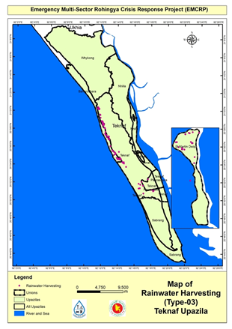

Map_01: Proposed location Map for Household Rainwater Harvesting Scheme (Type-C) at Teknaf Upazila, Cox’s Bazar

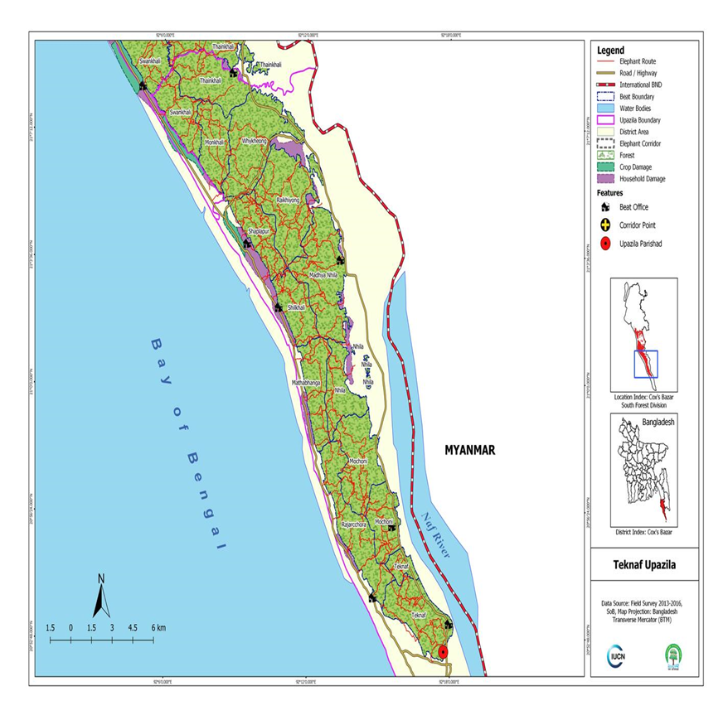

Map_02: Map of Elephant Migration Road/ Presence around Teknaf Upazila, Cox’s Bazar (ref. IUCN report 2016)

**Work Package: AF/WD-27 (Installation of Household Rainwater Harvesting System Type-C)**

**Environmental and Social Screening Form**

**Section A: Sub-Project Overview**

|  |
| --- |
| **Sub-project Location:**  This sub-project area is located under Sadar, Baharchara and St. Martin’s Islan Union of Teknaf Upazila, Cox’s Bazar. This E&S screening report comprises of 110 (One hundred and ten) Household level Rainwater Harvesting system “Type-C “will be installed in this host community area. Most of the sites are plain and some areas with medium to highland. There are available LGED’s pucca road, Marine drive, HBB road, earthen road or footpaths in the area. |
| **Land ownership:**  Required land for the installation of RWH systems ‘Type-C’ of the proposed sites will be provided by the individual Household in their own premise. So that no need to any land acquisition for the installation of RWH system ‘Type-C’. |
| **Expected construction period:** 09(Nine) months. |
| **Description of project intervention area and project influence area with schematic diagram (where relevant, indicate distance to sensitive environmental areas such as elephant corridors, water bodies, etc. and historical or socio-cultural assets):**  Adjacent to the scheme site under the RWH system option sub-project intervention area:   1. Impacted area: Approx. 27 square meters for each RWH system ‘Type-C’ 2. No structures, trees and livelihood will be affected. 3. Host community habitat, other assets relocation is not required. 4. Influence area: According to Layout diagram, the influence area is within the scheme area of 27 square meter per RWH system Type-C 5. Environmental sensitivity: Within the influence area of the sub-project no historical sites were identified. There is no evidence of presence of elephants in the sub-project influence area (checked with local IUCN representative). 6. All selected RWH system ‘Type-C’ locations have one and alternative locations. Alternative locations don’t have available scope of roof top catchment area |

# **Section B: Environmental Screening**

**B.1: Environmental feature of sub-project location**

|  |
| --- |
| **Description of cultural properties (if applicable, including distance from site):**  At the proposed RWH system sub-project scheme ‘Type-C’ areas, available Primary Schools, Collage, Local Bazar, Club, Grocery shop etc. were found. Apart from this, also found some natural forest land, Sea beach and offshore areas with Jhau forest which are far away from the proposed sites, BHH, culvert and RCC pucca road, HBB or earthen road. This selected land is almost plain and close to the LGED – UP HBB and pucca roads are existed close to the scheme area. In this scheme area, no wild animals (elephant), birds, turtle nest, migrated habitat, migration routes exist. However, none will be affected due to project intervention within 1-2 km from proposed scheme site. No significant environmental or social disturbance is anticipated due to construction activities. |
| **Location of environmentally important and sensitive areas:**  This location is not environmentally important and sensitive. It is a densely populated area. It’s located in the bank of the Bay of Bengal (Western side) and some areas are but the populous area is far away from the sea. The impacts are negative but small scale, site-specific within a relatively small area and adjustable by mitigation measures.  **(1) Within/near Elephant Migration Routes Yes/No*:**  **No.** According to UNHCR/IUCN prepared elephant migration route map (map attached 02), at present there is no Elephant corridor/ route due to deforestation.  **(2) Potential impacts on remaining forests in/around unions Yes/No*:**  **No**. At present the area has no natural forest. Some new plantations are seen raised by the inhabitants and by different organizations.  **(3) Other issues:** No more mentionable issues raised |
| **Dust:** Ambient air quality data was not readily available, but the quality is apparently good. During day time the number of vehicle movement on the road is too high. Dust is generated from the movement of vehicles such as motor cycle, truck, mini truck, tempo, auto rickshaw, tractor, private car, CNG, trolley, tractor etc. over the road surface which causes air pollution.  **Noise:** Noise in the sub-project area is not a major concern because noise level is within the tolerance level. Vehicles such motor cycle, bus, truck, mini truck, tempo, auto rickshaw, tractor, private car, CNG, trolley, tractor etc. move on the road surface adjacent to sub-project during day and night. These vehicles generate noise adjacent to the sub-project area but in most cases noise beyond the tolerable limit. |
| **Baseline soil quality:**  In the sub-project area soil is mainly in reddish brown, muddy, sandy & clay loam soil formation. The soils developing from the weathered sandstones tend to be sandy to clay loams. Presence of organic matter content in the soil is moderate.  **Landslide potential:**  **(high/medium/low, with explanation):**  **Low: The selected spots are far away from the hills.** |
| **Baseline surface water and groundwater quality (FE, TDS, fecal coliform, pH):**  **Surface water quality:** No surface waters. Only rainwater will be harvested from the capture area during rainy season.  **Groundwater quality:**  **N/A**  *Data source: Secondary data and field survey |
| **Status of wildlife movement:**  None of the information was found about the wildlife movement in or across the area. |
| **State of forestation:**  It has been observed that, proposed areas and surrounding locations are clustered & scattered, but man-made tree plantation is covered the targeted HC habitats presents over there. |
| **Summary of water balance analysis (For water supply scheme only):**  Please consider (i) water requirements of newly forested areas for plants' total evapotranspiration, (ii) new settlements water supply requirement for drinking water, household use, bathing and sanitation, (iii) replenishment rate from annual rainfall etc.   1. After installation of the proposed Rainwater Harvesting system (Type-C) about 5-6 people (per Household) will be directly benefited from each RWH system to meet their water requirements. 2. The average Annual rainfall in Cox’s Bazaar 3,524.1mm, average [relative humidity](https://en.wikipedia.org/wiki/Relative_humidity) 80%. Record high temperature was 37.2°C and low was 7.8°C (Data source BMD & BBS) 3. During least season people of Teknaf Upazila face acute scarcity drinking water. In the study “Domestic water quantity, service level and health, second edition” by WHO 2020, White, Bradley & White (1972) suggested that a daily minimum water consumption in tropical climates of around 3 L/person. They also proposed that, at 25 °C with moderate activity in the sun (e.g. agricultural work), approximately 4.5 L would be required to maintain hydration of an active person. DPHE planned to provide drinking water supports during acute season through collection and storing of rainwater and use 5 liters per person per day and for a household having 5 members will be able use 25 liters per day for at least 5 months from November to March. Calculation of a “Type-B” Rainwater Harvesting System, Quantity of rainwater collection would be 3750 liters (5 liters per person per day for a family comprised of 5 members for 5 months). For “Type-C” is designed as Rainwater Harvesting System with catchment area of 27 sqm and considered runoff coefficient is 70% or 0.70. So that the monthly and annual quantity of rainwater would be harvested according to the formula: Qty of water (Cum or Liter) =Catchment Area (A) X Average Rainfall X Runoff Factor as follows:  |  |  |  |  |  |  | | --- | --- | --- | --- | --- | --- | | **Month** | **Roof/Catchment area (sq. m) Type-C** | **Average Rainfall (mm)** | **Run off factor** | **Harvested Rainwater (Cu. M.)** | **Quantity (Lt) of water** | | January | 27 | 6 | 0.8 | 0.1296 | 129.6 | | February | 27 | 11 | 0.8 | 0.2376 | 237.6 | | March | 27 | 21 | 0.8 | 0.4536 | 453.6 | | April | 27 | 55 | 0.8 | 1.188 | 1188 | | May | 27 | 321 | 0.8 | 6.9336 | 6933.6 | | June | 27 | 970 | 0.8 | 20.952 | 20952 | | July | 27 | 1215 | 0.8 | 26.244 | 26244 | | August | 27 | 932 | 0.8 | 20.1312 | 20131.2 | | September | 27 | 496 | 0.8 | 10.7136 | 10713.6 | | October | 27 | 289 | 0.8 | 6.2424 | 6242.4 | | November | 27 | 54 | 0.8 | 1.1664 | 1166.4 | | December | 27 | 12 | 0.8 | 0.2592 | 259.2 | | Annual quantity of Rainwater harvested | | | | 94.6512 | 94651.2 |   **The details about the proposed Rrainwater Harvesting Filter- specification, filtration process and functional efficiency:** The proposed rainwater harvesting filter having 6 liters of inside volume capacity containing 2 types of filters: (1) primary filter of mesh size 100 and (2) the secondary filter of 5 microns which can perform efficiently the flow rate at 5 liters/second with 2-meters head having inlet Dia of 1.5 inches. Rainwater from the rooftop surface is captured and directed into the filter system through a 2 inches inlet diameter pipeline.  During movement of rainwater, primary filter (mesh size 100) captures the large size particles and pass into the secondary filter area (size of 5 Microns) which separate the smaller particles (impurities and contaminants present in the rainwater) effectively and then the clear water is stored in the filter’s vacuum space (6 liters capacity volume) then the cleared water moves into the reservoir tank for storing and use. |

**B.2: Pre-construction Phase**

|  |
| --- |
| **Information on Ancillary Facilities (e.g., status of access road or any other facility required for sub-project to be viable):**  RCC /Pucca and earthen roads are very close to the proposed RWH system (Type-C) scheme locations there are available herringbone bond, pucca, and earth road runs by the sub-project area which is the most feasible way of carrying construction materials (plastic pipes, industrial iron sheet/corrugated iron sheet, bamboo, iron angle, bricks, cement, rods, gravel, tank, etc.) to the construction site. |
| **Requirement of accommodation or service amenities (toilet, water supply, electricity) to support the work force during construction:**  Prior to commencement of construction work, contractor shall arrange accommodation facilities with toilet, water supply, electricity for the associates’ working personnel. |
| **Possible location of labor camp:**  Within the scheme area and very close to the sub-project sites. |
| **Requirement and type of raw materials (e.g., sand, stone, wood, etc.):**  i) Bricks, ii) Sand iii) Cement iv) uPVC pipe v) Gravel vi) water vii) Industrial Iron sheet etc. are the most common type of materials used in construction. |
| **Identification of access road for transportation (Yes/No):**  **Yes.** Most of the RWH systems sites beside 12-15 ft wide LGED Pucca Road and HBB roads are available and close to the proposed sites. |
| **Location identification for raw material storage:** Adjacent to the RWH system locations are very close to the construction sites and far away from steep slopes. |
| **Type and quantity of waste generated (e.g., Solids wastes, liquid wastes, etc.):**  **Solid type waste:**  i) Bricks, ii) Sand iii) Cement iv) uPVC pipes v) Iron sheet vii) Gravel etc. It is difficult to give exact figures of pre-construction waste produced on a RWH site. However, 20-30 kg of waste may be produced for each site. |
| **Approx. area (in square meters) of vegetation and soil in the right-of-way, borrow pits, waste dumps, and equipment yards:**  No valuable vegetation presence in proposed construction sites approx. 21sq. meter land per RWH system Type-C. |
| **Possibility of stagnant water bodies in borrow pits, quarries, etc., encouraging for mosquito breeding and other disease vectors:**  **(High/Medium/Low with explanation):**  **Not significant** accumulation in borrow pits reported around or adjacent to the sub-project area. |
| **Disturbance or modification of existing drainage channels (rivers, canals) or surface water bodies (wetlands, marshes):**  **(High/Medium/Low with description):**  **Low.** The proposed sites are located far away from Naf River and the Bay of Bengal So that this river and channel shall not be affected by discharging waste and unwanted materials generated from construction activities. |
| **Destruction or damage of terrestrial or aquatic ecosystems or endangered species directly or by induced development:**  **(High/Medium/Low with description):**  **Low.** The proposed site of the scheme intervention, avoid the area with presence of terrestrial, aquatic ecosystems and endangered species and there is no any possibility of destruction or damage of lives and endangered species and ecosystem. So that the impact is very low in the sites. Species and ecosystems have not been reported whose lives or movement may be disturbed (i.e., Insects - Ant, bees, earthworm, reptiles, turtle, birds etc.) by the scheme activities.  Major Terrestrial Fauna species found in sub-project area are Common Toad (*Bufo melanostictus*), Yellow Speckled Wolf Snake (*Lycodon zara*), Red-vented Bulbul (*Pycnonotus cafer*), Red-wattled Lapwings (*Vanellus indicus*) and Hoopoe (*Upupa epops*). Some Aquatic fauna also found in the sub-project area are Pond Heron (*Ardeola)*, Little Cormorant (*Phalacrocorax niger*), White-breasted kingfisher (*Halcyon smyrnensis*), Common King Fisher *(Alcado athis)* and Catla *(Catla catla).*  Major Terrestrial floras in sub-project area are Acacia *(Acacia auriculiformis), Bettle nut (Areca catechu )*, Coconut (Cocos nucifera), Bamboo (Bambusa sp.), Fern *(Drynaria quercifolia) and* Date palm *(Phoenix Sylvestris).* Some Aquatic flora also found in the sub-project area are Floating Gress (*Echinoclo acolonum*), Kalmi (*Ipomoea aquatic*), Kachurypana (*Eichhornia crassipes*) and Topapana (*Pistia strateotes*). |
| **Activities that can lead to landslides, slumps, slips and other mass movements in road cuts:**  There is no such activity that cause landslide. |
| **Describe possible traffic movement impacts on (unwanted) light, noise and air pollution:**  No traffic movement impacts on light but low effects of noise and air pollution. |

High = Likely to cause long-term impacts or over large area (>1.00sqkm); Medium = Likely to cause temporary damage or over moderate area (0.5 to 1.00 sqkm); Low = Likely to cause little, short-term damage and over small area (<0.50 sq.km)

**B.3: Construction Phase**

|  |
| --- |
| **Type and quantity of waste generated (e.g., Solids wastes, liquid wastes, etc.):**  **Solid waste:**  i) Bricks, ii) Sand iii) Cement iv) uPVC pipes v) Gravel vi) Iron sheet etc. It is difficult to give exact figures of construction waste produced on a HH RWH system. However, 20-30 kg of waste may be produced from each site.  **Liquid waste:**  During construction period, fecal sludge will be generated from labor camp. It is difficult to give exact figures of construction waste construction site. |
| **Type and quantity of raw materials used (wood, bricks, cement, water, etc.):**  **Raw materials:**  i) Bricks, ii) Sand iii) Cement iv) uPVC pipes v) Water vi) Iron sheet viii) gravel etc. by the concerned contractor firm.  **Quantity:**  It is difficult to provide exact figures of construction materials that will be used on a mini pipe water supply construction site. However, 500 kg of raw materials may be required for each site. |
| **Approx. area (in square meters) of vegetation and soil in the right-of-way, borrow pits, waste dumps, and equipment yards:**  No valuable vegetation presence in proposed sub-project construction sites. So, vegetation will not be affected by construction work. |
| **Possibility of stagnant water bodies in borrow pits, quarries, etc., encouraging for mosquito breeding and other disease vectors:**  **(High/Medium/Low with explanation):**  **Low.**  Trenches for laying of pipelines will be required. These can potentially store stagnant water for short period of time during and after rain events. The top soils in the sub-project are is sandy and the water should drain away quickly. |
| **Disturbance or modification of existing drainage channels (rivers, canals) or surface water bodies (wetlands, marshes):**  **(High/Medium/Low with description):**  **Low.**  It’s an island of the Bay of Bengal. But it should not be affected due to construction activities. |
| **Destruction or damage of terrestrial or aquatic ecosystems or endangered species directly or by induced development:**  **(High/Medium/Low with description):**  **Low.**  Under these scheme establishment interventions, the effect of destruction or damage of lives and endangered species ecosystem is very low in the site area. Species and ecosystems have not been reported whose lives or movement may be disturbed (i.e., Insects - ant, bees, earthworm, reptiles, turtle, birds etc.) by the scheme activities. |
| **Activities that can lead to landslides, slumps, slips and other mass movements in road cuts:**  Construction of the sub-project components can lead to low scale effects of land slide/slips. The impacts are expected to be negative, short-term, site-specific within a relatively small area and can be minimized by mitigation measures. |
| **Erosion of lands below the road bed receiving concentrated outflow carried by covered or open drains:**  **(High/Medium/Low with description):**  **Low.**  Potential erosion may occur when moderately to highly sloping terrains are disturbed for the construction of RWH sites and pipe lines. The impacts are expected to be negative, small scale, site-specific within a relatively small area and minimized by mitigation measures. |
| **Anticipated impacts on ground and surface water encouraging for disease vectors:**  **(High/Medium/Low with explanation):**  **Low:** Possible risk due to leaking or overflow of sludge from the septic tank and contaminated diseases vectors goes into the nearby drains, waterbodies or dumping into the environment or in nearby dug holes. If properly managed the leaks and sources of contamination the impact shale low. |
| **New Identified Potential Impact during construction work in the field:**  During construction work in the field new identified impact shall be considered with appropriate mitigation measures and ESMF shall be updated with the new identified impact with suggested mitigation measures shall be sent to the Bank for approval. |
| **Describe possible traffic movement impacts on (unwanted) light, noise and air pollution:**  No traffic movement impacts on light as all vehicular movement will be during day time. Some temporary, localized effects of noise and air pollution can occur due to truck movements. |

High = Likely to cause long-term impacts or over large area (>1sqkm); Medium = Likely to cause temporary damage or over moderate area (0.5 to 1sqkm); Low = Likely to cause little, short-term damage and over small area (<0.5sqkm)

**B.4: Operation Phase**

|  |
| --- |
| **Activities leading to health hazards and interference of plant growth adjacent to roads by dust raised and blown by vehicles:**  Dust may be produced but not significant if care given after collection of water and if the roof top No dust will be Increase in dust may cause health problems to workers at O & M period. Improper use of personal protective equipment (PPE) and lack of safety procedures may cause injuries. Site-specific within a relatively small area and adjustable by mitigation measures. |
| **Chance of long-term or semi-permanent destruction of soils**:  **(High/Medium/Low with description):**  **Low.**  Some localized semi-permanent destruction of soils may occur during maintenance of water option and collection points. |
| **Possibility of odor and water, soil quality impacts from SWM and FSM disposal system**  **(High/Medium/Low with description):**  N/A |
| **Possibility of stagnant water bodies in borrow pits, quarries, etc., encouraging mosquito breeding and other disease vectors:**  **(High/Medium/Low with explanation):**  **Low.** There are low possibilities of stagnant water occurring in the operation period if there are leakages in the water supply scheme, including overflow of overhead tanks. |
| **Likely direct and indirect impacts on economic development in the project areas by the sub-project:**  Local labor will be involved in maintenance activities. Safe drinking water supply will be helpful to reduce water scarcity crisis of the host community and improve their health condition. |
| **Extent of disturbance or modification of existing drainage channels (rivers, canals) or surface water bodies (wetlands, marshes):**  **(High/Medium/Low with description):**  **Low.**  It’s an important landscape beside the Bay of Bengal so that nothing shall be dumped in the drainage affected by the waste generated from the construction activities. |
| **Extent of destruction or damage of terrestrial or aquatic ecosystems or endangered species directly or by induced development:**  **(High/Medium/Low with description):**  **Low.**  Operation and maintenance activities of Rainwater Harvesting system scheme will be localized and temporary in nature. Species and ecosystems have not been reported whose lives or movement may be disturbed (i.e., Insects - Ant, bees, earthworm, reptiles, turtle, birds etc.) by the scheme activities. |
| **Activities leading to landslides, slumps, slips and other mass movements inroad cuts:**  Buried pipe channels can form preferential runoff paths, causing localized erosion. Also, leaking pipes can lead to slope instability. |
| **Erosion of lands below the road bed receiving concentrated outflow carried by covered or open drains:**  **(High/Medium/Low with explanation):**  **Low.**  Low possibility to erosion of land at RWH system site. |
| **Describe possible traffic movement impacts on (unwanted) light, noise and air pollution:**  Localized impacts on noise and air pollution from maintenance vehicles movement can occur. All maintenance works will be conducted during daytime – so no light impacts expected. |
| **Type and Chance of hazards affecting sub-project and labor camp location (e.g., flooding, landslides, cyclones, etc.):**  **High/Medium/Low with description):**  Hazard Type(s): Cyclone, Flash Floors and the chance of natural hazards affecting Community Water Option structure and labor sheds is **Low** and only possibility as seasonal based. |
| **Accessibility to the closest disaster shelter (Easy/Difficult with description):**  In the RWH system operations phase the accessibility to the closest disaster/ cyclone shelter is almost easy for the community. Noted that active cyclone shelters to the sub-project areas. |

High = Likely to cause long-term impacts or over large area (>1sqkm); Medium = Likely to cause temporary damage or over moderate area (0.5 to 1sqkm); Low = Likely to cause little, short-term damage and over small area (<0.5sqkm)

**Section C: Social Screening**

# **C.1 General Labor Influx Screening**

|  |  |
| --- | --- |
| **Key Screening questions** | **Aspects to Consider** |
| Will the project potentially involve an influx of workers to the project location, and will the influx be considered significant for the local community? | **No**. Require number of total skilled and unskilled Labor for each RWH Type-C system is respectively 1-2 and 2-5. All the skilled & unskilled labor will be engaged from the Host community. No additional foreign labor will be engaged. All the skilled labor will be stay at labor shed if required. The size of the labor shed will be 120 square feet. So, no significant influx to be considered for the local community. |
| Is the project located in a rural or remote area? | **Yes**. The project location is in a host community area demarcated by the targeted HHs. Local Government (Union Parishad) authority and belongs to Sadar, Baharchara and St. Martin’s Island Union under Teknaf Upazila mostly are semi forward to remote area. Population is estimated around 5-6 per RWHS. The frequency and extent of the communication between the local community and outsiders are normal, and not specially controlled by the respective LGI (union/Upazila) or any other authority. |
| Based on the socioeconomic, cultural, religious and demographic qualities of the local community, population and the incoming workers, is there a possibility that their presence or interaction with the local community could create adverse impacts? | **No.** It is expected that the presence of the skilled and unskilled local labor (HC) will not create any adverse impacts. The project will benefit the targeted host communities. There will be a code of conduct for the labors to follow, which will be monitored by the PMU and local DPHE on a regular basis. |
| Consultation with Host Community People and relevant stakeholders (SH) | During screening and site identification local DPHE and PMU has conducted **five (5) consultation** meetings with primary and secondary stakeholders and HCs. The stakeholders include LGIs (UP Chairman, Councilors, WATSAN committee, Local Elites, Contractor team and targeted host community. In addition to the above-mentioned meetings, the E&S team & local DPHE has undertaken many consultations with male and female members of the concerned host communities. Through the coordination and linkage activities of the project, the authorities have accomplished some formal view exchange meetings, individual household visits, FGD, Tea Stall discussion and other consultation meetings. |

**C.2 Land acquisition and stakeholder screening**

|  |  |  |  |  |
| --- | --- | --- | --- | --- |
| **Probable Involuntary Resettlement Effects** | **Yes** | **No** | **Not Known** | **Remarks** |
| **Involuntary Acquisition of Land/ Land Donation/ Land Taking** | | | | |
| 1. Will there be any land acquisition? |  | √ |  | No. The required Land is around 21 sq. meter (for installation of RWH Type -C system (capture area and Reservoir tank plus basin area) |
| 2. Is the project construction site known? | √ |  |  | The site location is obviously known and has been selected with the recommendation of respective user HH & Local DPHE and WATSAN committee. |
| 3. Who manage the land? | √ |  |  | Land is owned / possesses by the HH as homestead land within his/her premises. No any land acquisition has to be done and as per ESMF – RPF formal process and proposed land is currently empty (see site location photos). |
| 4. Will easement be utilized within an existing Right of Way (ROW)? CRP (Common Resource Property) | √ |  |  | In the proposed HC area provision is available be utilized within an existing Right of Way (ROW) within this proposed RWH system scheme under EMCRP. |
| 5. Will there be loss of Community people house, agricultural carps, trees, and other productive or fixed assets due to project intervention? |  | √ |  | No: habitat/ shelters will be affected. During construction of RWH site development no asset, or crop land will be affected, contractors are responsible to mitigate the impacts following the RPF. |
| 6. Will there be loss of businesses or enterprises due to project intervention? |  | √ |  | No |
| 7. Will there be loss of income sources and means of livelihoods due to project intervention? |  | √ |  | No |
| **Involuntary restrictions on land use or on access to legally designated parks and protected areas** | | | | |
| 8. Will people lose access to natural resources, communal facilities and services? |  | √ |  | No |
| **Information on Displaced Persons:** | | | | |
| 9. Any estimate of the likely number of persons that will be displaced by the Project? [√ ] No [] Yes  If yes, approximately how many? | | | | |
| 10. Are any of them poor, female-heads of households, or vulnerable to poverty risks? [√] No [ ] Yes | | | | |
| 11. Are any displaced persons from indigenous or ethnic minority groups? [√ ] No [ ] Yes | | | | |
| During Screening, project authority will conduct consultation with the primary and secondary stakeholders and provide their observations in the following sections (12 to 223) | | | | |
| **12: Who are the stakeholders of the project*?*  Please provide a summary of consultation meetings with stakeholders and the affected community.**  Under EMCRP additional Financing Rainwater Harvesting System sub-project of Teknaf Upazila the key stakeholders are local community, Labors, communities/organizations within the project influence area indirectly affected by project activities. Also, the, relevant Government line departments/agencies, Environment and Forest Department and, NGOs involved at WASH interventions of the proposed local host communities. For determining the environmental and social impacts associated with Water Option sub-project implementation, DPHE, PMU has been providing importance on involving primary and secondary stakeholders of the scheme area. Therefore, to collect local knowledge for baseline conditions, understand perceptions of the community regarding impact significance, propose meaningful mitigation measures during survey of E&S Screening, an attempt has been made to consult with relevant stakeholders and DPHE officials to obtain their views on Water Option sub-project interventions.  The Community consultations were conducted through a mix of conventional approach which involved as Participatory Community Consultations (PCC), Focus Group Discussion (FGD), Key Informant Interview (KII) and one-to one interview, during the environmental and social study of the proposed sub-project in conformity with the WB’s ESMF guidelines. However, for better understanding the socio-economic and environmental condition 5 **(five)** consultations with local community have been conducted in the sub-project study area (*Appendix-2).*  Aiming to establish the RWH scheme at UP and DPHE assigned HC area by the respective WATSAN Committee, under EMCRP (DPHE part) initially GIS specialist, hydrogeologist located the scheme area, E&S consultants, Local DPHE authority and other development partners have conducted a series of consultations with the targeted host community and people on the following issues: Project introduced Social and Environmental safeguard issues, grievance redress mechanism (GRM), possible social environmental and economic effects, livelihoods options, discussions on minimizing the laborer conflict among local host communities, Infrastructure WASH, hygiene, gender-based violence (GBV), forestation, elephant corridor, waste, sludge management, benefits of safe drinking water options by establishment of mini piped water supply and other WASH schemes. The respective Local elites, community man & women also participated in the consultations.  Noted that, most of these interventions are to be situated on the HC areas and water user group (WUG) HH member (among water user 10 HHs) occupied land. The E&S screening team have followed ESMF- RPF and PMU consent. | | | | |
| In the consultation session E&S aspects of the project interventions, above-mentioned issues were discussed as potentially occurring at the project sites of HC. The community welcomed and appreciated the EMCRP initiatives on RWH system for safe water considered as one of their priority needs for secured and better livelihoods. They opined that there is no Elephant corridor and no scope of Elephant/Human conflict over there. Through the consultation meeting, the host community were made aware of and sensitized on E&S safeguard issues, precautions, child safety, any chances of displacement of various structures, relocations of local institutions if any objection and complaints.  The community consultations were conducted with the following objectives: (i) to intrude awareness of the stakeholders on Community Water Option- DTW and to seek suggestions for planning and designing of the water option sub-project (ii) to identify the need and concern of the local public, (iii) to assess cultural patterns and behavior of local communities. Stakeholder consultation was targeted at people/communities who may – directly or indirectly, positively or negatively- be affected by the outcomes of the RWH system. The consultations were conducted at two different tiers of stakeholders: Local people and different organization representatives who are concerned about the sub-project. All of the proceedings and interactions of consultation and FGD have been recorded.  **Feedback, Suggestions, and Recommendations of the Participants FGD:**  The participants’ feedback, suggestions, and recommendations listed below:   * During consultation the participants were requested to provide support to establish Rainwater Harvesting System to have provision of safe water at Teknaf Upazila and cooperate in O&M of the water options. * The participants expressed their concern about employment opportunities and requested to engage labor from local community so that they can manage their livelihood. * During construction work they also request to maintain and obey the proper safety and security measures   Most of the participants opined that they all will be benefitted by community water option - safe water availability at proposed areas.  Individual level consultation with project interest and influence parties (UP, WatSan Committee, Local DPHE) representatives were conducted in consistence with consultation objective during sub-project selection stage to have their idea, concern, segregation about the proposed sub-project. Consultation outcome with them is consolidated here in below:  **Responds of WatSan Committee members / UP Chairman:** UP and WatSan Committee members are ready to support EMCRP-DPHE, if they face any obstacle to implementing the RWH system;To keep boundary of the scheme areas and hang a signboard as soon as possible including name of executing agency, types of intervention, address of contractor, project duration, funding agency name and so on.Engage the Local community to implement the RWH system sub-project.To keep temporary bin for waste collection during scheme implementation should arrange and regular disposal also need to be assured;Community water option boring and collection point sites not shall be allowed in the bank of natural water body except ensuring adequate mitigation;Construction wastes that to be generated should be disposed regularly at designated sites. | | | | |
| **13: What social and cultural factors affect the ability of stakeholders to participate or benefit from the proposed policy or project?**  None. | | | | |
| **14: Are project objectives consistent with their needs, interests and capacity?**  Yes, the EMCRP project’s objectives are consistent with the respective stakeholders, host community, needs, interests and capacity in the project areas. | | | | |
| **15: What will be the impact of the project or sub-project on the various stakeholders, especially women and vulnerable groups?**  In the whole E&S screening process it has been revealed that a very positive impact would be created in the host community by establishing the Rainwater Harvesting system sub-project. The E&S team has tried to understand the vulnerability of the host community especially the women and children, disable vulnerable group. During dry season women and children have to collect water from the sources far away from their houses. Some people collect contaminated water from chara/stream. Some of them opened that suffer from scarcity of water for drinking as well as for domestic uses, even they cannot bath in one/two weeks. Under the sub-project of the host community, the stakeholder’s perception is that the overall project impacts will be positive and they expected to have the project be implemented. The influx is straining existing infrastructure and degrading the already resource-constrained social service delivery system and the environment at HC areas. Access to improve water quality and quantity is a priority of this sub-projects. In the context of environmental and social aspects, these projects are planned for the adjustment of host communities in Cox’s Bazar to establish need-based Social Protection system which would organize the victim vulnerable groups.  **Positive Impact:**  RWH schemes Type-C is basically designed for the pro-poor people having kacha houses so that this opportunity will reduce their vulnerability. After implementing the RWH schemes Type-C at different locations of Teknaf Upazila the people will get sufficient safe water for drinking & other domestic uses, which will reduce their suffering of collecting water to meet up the basic needs. This RWH Type-C system will ensure pollution free potable water for them.  **Negative Impact:**  Due to operation of RWH system Type-C scheme the adverse impact will be zero. there will have no significant impact. Beside these, there will be medium level of negative impact, from waste (mud, liquid waste from labor shed) generated by constructing the RWH system. However, the anticipated impact will be short-term and negative and localized. Further, if construction site is not fenced properly then children may face accident. | | | | |
| **16: hat social risks might affect project or sub-project success?**  As per the **field** visit findings and consultation meeting with targeted host community and different stakeholders, Under the RWH system Type-C for screening process it has been revealed and perceived that some social risks might occur due to the establishment of the scheme interventions.  In order to implement the **RWH Type-C** scheme tasks, additional labor from outside such as technicians, masons will also be engaged which may cause as a risk of local social conflict. The gender and GBV issues (i.e., human trafficking, eve teasing, etc.) are being addressed through need-based activities. As a mitigation measure, the Social Safeguard team and grievance redress committee (GRC) will be developed. A complete Gender action plan has already been developed and approved, a full time Social Development consultant has been assigned to oversee and solicitate /mitigate the GBV based issues for this community water option sub-project. The respective ESMF based GRM, is keeping abreast on GBV occurrences and will guide the community through consultation meetings and counseling. The E&SS team and local DPHE shall be concern about sensitive issues of the proposed host community areas on social, cultural, religious, gender, disabilities, orphaned and vulnerable children. However, for adopting the project, considering the E&S safeguard issues and community consultation DPHE may determine possible ways and options to mitigate solicitate the constraints and risks during the implementation of **Rainwater Harvesting system Type-C.** | | | | |

**C.3. Social Capital Format**

The objective is to list down the various types of social institutes/bodies working in the host community, intended **RWH system Type-C** influence areas for the possible inclusion in the management, and monitoring of the projects. **Presenting** **the list with the name** of social institutes/ bodies under the given categorization along with the following information. Use separate sheet for each category of social institute/body. The information can be collected through secondary sources such as LGIs and UN agencies or different development organizations that are involved with the Rohingya crisis projects, etc.

| **Type of Social Institutes/bodies** | **Name of Institution** | **Contact Person and Address and phone number** | **Primary areas of Work** | **Coverage areas in the camp and communities** |
| --- | --- | --- | --- | --- |
| **Government Organizations** | UNO  SAE, DPHE  EE, DPHE  DC | Md. Adnan Chowdhury  UNO, Teknaf Upazila, Coxs Bazar  [unoteknaf@mopa.gov.bd](mailto:unoteknaf@mopa.gov.bd)  Md. Faruk Hossain  Sub Assistant Engineer  DPHE Teknaf Upazila, Cox’s Bazar  [Md. Mustafizur Rahman](http://dphe.coxsbazar.gov.bd/en/site/officer_list/%E0%A6%AE%E0%A7%8B%E0%A6%83-%E0%A6%AE%E0%A7%8B%E0%A6%B8%E0%A7%8D%E0%A6%A4%E0%A6%BE%E0%A6%AB%E0%A6%BF%E0%A6%9C%E0%A7%81%E0%A6%B0-%E0%A6%B0%E0%A6%B9%E0%A6%AE%E0%A6%BE%E0%A6%A8), DPHE,  Executive Engineer, Cox’s Bazar,  [xendphecoxsbazar@gmail.com](mailto:xendphecoxsbazar@gmail.com)  …………………………………  Md. Shaheen Imran  DC, Cox’s Bazar  *dccoxsbazar@mopa.* | Overall Coordination of GOB dept, Dev partners, NGO, INGO, Volunteers,  Management of HOST Crisis in BD. Refugee Relief and Repatriation, Site management, | Host Community, synchronizing with Host, E&S aspects, Elephant corridors, conserves NR. Establish proper road communication. |
| **National Organizations** | Not yet on boarded | the database web link:  https://www.humanitarianresponse.info/en/operations/bangladesh/document/wash-sector-coxs-bazar |  |  |

# **Section D: Environmental and Social Screening Summary**

### **Environmental Screening Summary:**

Based on the above environmental and social screening, potential impact of implementing the proposed intervention on different parameters of environmental and social aspect with their consequence; mitigation measures and suggestive monitoring plan with responsible parties of implementation and supervision of Rainwater Harvesting system sub-project scheme under **Type-C** have been summarized as below:

| **Section** | **Main Env. and Social Impacts** | **Impact Significance\*** | **Suggested Mitigation Measures** | **Person/ Institution Responsible** | **Monitoring Suggestions** | |
| --- | --- | --- | --- | --- | --- | --- |
| **Indicators** | **Frequency** |
| **1: Sub-Project Interventions** | **Air Quality** | Under the sub-project intervention, the overall score is **low**. | * + Make sure to do limited earthworks;   + Watering of dry exposed surfaces and stockpiles of aggregates at least twice daily, as necessary; (spreading of crushed gravel over backfilled surfaces;   + Limiting the speed of construction vehicles in access roads and work sites to a maximum of 20 kph. | Construction Contractor and monitored by Environmental Consultant of PMU | * Number of complaints from stakeholders regarding vehicle covered by tarpaulin; * Records of air quality inspection; | If possible, air quality test (CO, PM) once in the construction period in the winter season. |
| **Soil contamination and erosion** | Under the sub-project intervention, the overall score is **Low.** | * Any earthwork during construction of catchment and platform structure shall be done in scheduled time avoiding rainy day. * The earthwork sites where the exposed land surface is vulnerable to runoff shall be consolidated and/or covered with vegetation/geotextile membrane to hold the soil. * Channels, earth bunds, netting, tarpaulin and or sand bag barriers shall be used on site to manage surface water runoff and minimize erosion. * The construction yards shall be kept to reduce the erosive potential of surface water flows elsewhere. * More details provided in ESMP | Construction Contractor monitored by Environmental Consultant of PMU | * No visible degradation to nearby drainages, * Canals or water bodies due to soil erosion. | Weekly, especially after rain events. |
|  | **Hydrology (Rainwater)** | Under the sub-project intervention, the overall score is Low. | * All precautions shall be maintain during collection of water from the catchment area. * Monitor water quality according to the environmental management plan. * More details provided in ESMP | Construction Contractor and monitored by Environmental Consultant of PMU | * Areas for stockpiles, storage of fuels and lubricants and waste materials; | If needed water quality test after reserving the tank. |
| **2. Pre-construction Phase** | **Sanitation, water supply** | Under the sub-project intervention, the overall score is **low.** | * Provide suitable housing, adequate supplies of potable water, and toilet and bathing facilities within the housing area for the assigned laborer. * Provide means for disposing of wastewater from toilets, baths and food preparation areas either through a septic tank and soak away, or holding tank with removal by vacuum truck. * More details provided in ESMP. | Construction Contractor and monitored by Environmental Consultant of PMU | * Site-specific H & S Plan; * Records of supply of uncontaminated water; * Record of Health & Safety orientation trainings; * Condition of sanitation facilities for workers | Visual inspection monthly basis |
| **Impact on Existing drainage:** drain may block, due to storage of construction materials on or next to the drain. | Under the sub-project intervention, the overall score is **low** | * The Contractor will not be allowed to store construction materials beside drains * Regular monitoring is essential * If any materials fall within the drain, contractor will clean the drain immediately. | Contractor and monitored by Environmental Consultant and PMU | * List of materials and sources of materials; * Storage site away from the drain | Weekly |
| **Transportation impacts** | Under the sub-project intervention, the overall score is **low.** | * All vehicle movement shall be allowed during the day time * Speed needs shall be limited to 20kmph * Contractor’s responsibility to verify the suitability carrying, loading and unloading of materials by trucks or others transport and head load arrangement. | Construction Contractor and monitored by Environmental Consultant and PMU | * Check the vehicle pool. * Record of regular inspection. * Record of accidents/ incidents | Monthly monitoring. |
| **Storage of construction materials** can cause pollution or land slips | Under the sub-project intervention, the overall score is **low.** | * The contractor shall submit a method statement and plans for the storage of hazardous materials (fuels, oils, and chemicals) and emergency procedures. * Proper stockpiling/ storage of construction materials at the site proposed by the contractor & approved by the Environmental Consultant of PMU. * Proper covering of dust producing materials with polythene sheet, * Spills/ hazardous substances should be disposed of at the site proposed by the contractor & approved by the Environmental Consultant of PMU to avoid soil/ water contamination. | Contractor and monitored by Environmental Consultant and PMU | * List of materials and sources of materials; * Storage site away from steep slopes and has proper bonding | Weekly |
|  | **Destruction or damage of terrestrial or aquatic ecosystems** | Under the sub-project intervention, the overall score is **low.** | * Vegetation clearing work will be done only where subproject intervention will take place. * More details provided in ESMP | Contractor and monitored by Environmental Consultant of PMU | * Ground openness in the intervention area | Weekly |
| **3. Construction Phase** | **Wastes (earth, mud, HDPE cuttings, etc.)** | Under the sub-project intervention, the overall score is **Low.** | * Wastes must be placed in the designated bins which must be regularly emptied. * All waste must be removed from the site and transported to a disposal site. * More details provided in ESMP | Construction Contractor and monitored by Environmental Consultant of PMU | * Complaints from community; * Regular inspection of waste management activity; * Waste disposal record. | As work weekly progresses |
| **Stagnant water risk** | Earth excavation will be required for pit placement. Water stagnant may occurs if the place keeps open for long time after earth excavation. **Low.** | * The top soils in the sub-project are sandy, the water should drain away quickly * The contractor should arranger proper water facilities * Proper PPEs are essential during construction work. | Construction Contractor foreman and monitored by Consultant and PMU | * Water stagnant beside household toilet area | Daily during construction |
| **Storage of materials**  (Creating dust/ air pollution liquid/ hazardous substance i.e. oil, chemicals etc., Risk of crime) | Under the sub-project intervention, the overall score is **Low** | * By the Union Parishad and DPHE to identify the storage site and other requirements, which will be approved by PMU and consultants * More details provided in ESMP | Construction Contractor and monitored by Environmental Consultant of PMU | * List of materials and sources of materials; | Monthly basis during implementation phase. |
| **Impact on Drain & Aquatic Environment** by discharging solid & liquid wastes from construction site & labor camp into nearby drain & through the drain those wastes can fall into canal water | Under the sub-project intervention, the overall score is **Low** | * Generated waste and construction debris shall be properly disposed in accordance with the approved designated disposal site(s); * Separate waste collection bins, for organic and inorganic wastes, shall be provided throughout the construction sites, whereby all waste collection bins be regularly emptied and cleaned; * Contractor will be responsible to control the workers from discharging of construction waste into water bodies. | Contractor and monitored by Environmental Consultant and PMU | * Frequency of emptying the waste bin * Existence of waste bin | Monthly basis during implementation phase. |
| **Erosion of land** | Under the sub-project intervention, the overall score is **Low** | * During construction work (especially for earth excavation) proper slope protection is essential. * During backfilling work proper compaction is essential (as per spec.) * Avoid earthwork during monsoon * Control surface run off to reduce soil erosion through mulching, temporary retaining wall made of bamboo and sheet though there are less possibilities of happening such situation. * Safe disposal of drainage water to avoid stagnation | Construction Contractor foreman and monitored by Consultant and PMU | * No visible degradation to nearby drainages or water bodies due to soil erosion at/near sub-project site. | Daily during earth excavation work & work below GL |
| **Noise pollution** | Under the subproject intervention the overall score is **Low.** | * Consultation with affected people; not to operate noisy equipment during working and operations time (17:00 – 06:00); * Sound suppression for equipment; * Ear protection for workers. * Conduct noise quality monitoring as per ESMP. | Construction Contractor and monitored by Environmental Consultant of PMU | * Number of complaints from stakeholders; Use of silencers in noise-producing equipment and sound barriers; * Noise Level following decibel meter (dB) | Inspection by PMU and supervision consultants on monthly basis; |
| **Incidental or Accidental issues:**  Injuries of staffs and workers in the site | Under the subproject intervention the overall score is **Low.** | * Make sure to carry out a risk assessment on risk and possible dangers * Make sure to provide appropriate training to the engaged staffs and labors. * Provision to maintain proper PPE wherever necessary * Any incidents or accidents shall be recorded, documented and reported to the Bank through PMU, EMCRP within 24 hours of event happened. | Construction Contractor and monitored by Environmental Consultant of PMU and update the bank through PMU/DPHE | * No of accidents or incidents, Record register | Inspection by PMU and daily update from site |
| **Safety Issues** /impact may decline if construction management not works rightly. | Under the subproject intervention the overall score is **Low.** | * Make sure to available safety materials to the construction site and all laborers adhere to safety requirements during construction. * Safety managers monitor the construction activities on a regular basis. * Unauthorized entry to the site area shall completely be prohibited and the site will be properly fenced with a single entry. * Properly maintained instruments as well as hazardous materials on the site | Construction contractor | * Environmental Consultant of PMU | Regularly basis |
| **New impact identified in the field** | Under the sub-project intervention impact | * If any new impact identified in the field during construction shall be screened which shall be included in the ESMP * Environmental and Social Management Plan (ESMP) will be updated as needed to address the new identified impacts.   Updated ESMP shall be shared with the bank through proper authority. | Construction Contractor and monitored by Environmental Consultant of PMU and update the bank through PMU/DPHE | * Records of new impact | During construction period as and when required |
| **Air pollution** | Under the subproject intervention the overall score is **Low**. | * Water spraying for dust control; construction materials with potential for significant dust generation shall be covered; no smoke emitting equipment; and limiting speed of construction vehicles in access roads and work sites to maximum of 20 kph. * More details provided in ESMP | Construction Contractor and monitored by Environmental Consultant of PMU | * Location of stockpiles; * Number of complaints from stakeholders; * Records of air quality inspection; Air quality test report | Air Quality: PM10 PM2.5, SPM and SO2 test once in construction period. |
| **4. Operational Phase** | **Health & Safety Hazard** | Users can be affected if water is contaminated during collection, storing period and overall score is **Low.** | * Ensure to clean the catchment surface of the structure during collection and storing rainwater in the reservoir | User of the RWH system | * Register | During containment cleaning work. |
| **Noise pollution** | Under the subproject intervention the overall score is **Low.** | * limiting speed of maintanence vehicles in access roads and work sites to maximum of 20 kph.   Transportation of the fecal sludge & other liquid waste shall be carried during the scheduled times, and mainly during the day | Long-term responsibility shall be determined by DPHE | Noise from maintenance vehicle | If needed or possible, During Maintenance work |
| **Accident or Injuries** | Under the subproject intervention the overall score is Medium. | * Ensure proper training given to all staff * Ensure PPE used by all staff * For any accidental issue occurred in the site shall be informed to the DPHE within 24 hours of the event. | Contractor: up to contractor’s liability period Long-term responsibility shall be determined by DPHE | Accidents Register  Records of accidents and safety inspection; | Environmental Consultant of PMU |
| **Air pollution** | Under the sub-project intervention, the overall score is **Low.** | * Limiting speed of construction vehicles in access roads and work sites to maximum of 20 kph.   More details provided in ESMP | Construction Contractor up to defect liability period. Consultant and PMU | Dust due to vehicular movement | If need or possible, During Maintenance vehicle movement |
| **5: Potential Natural Hazards** | **Cyclone** | Seasonal or weather depression and the overall score is **medium**. | * Make sure that the beneficiary and the working force at the site shall be aware about the early cyclone/ disaster warnings and take actions for safety and security of manpower and .other resources. * Mobilize and coordinate with the disaster management team for integrated preparedness activities and responses. | Construction Contractor up to defect liability period. Consultant and PMU | * Weather Forecasting procedure/ Depression | Site inspection weekly and monthly basis. |
| **Flash Flooding** | May occur due to runoff from rainstorms and the overall score is **low**. | * Protection shall be taken when a rainstorm is imminent * If there is a heavy rainfall in a higher area, it affects the lower areas. Therefore, if there is heavy rainfall in any high area, advance warning and measures shall be taken in the lower areas. * The embankment shall be constructed considering the damage caused by flash floods. | Construction Contractor up to defect liability period. Consultant and PMU | * Weather Forecasting procedure, Rainstorms | Site inspection weekly and monthly basis during rainy season. |
| **Fire** | The main cause of fire is carelessness. Ignorance goes hand in hand with carelessness.  The overall score is **low**. | * Make sure to keep fire extinguishers/prevention system at every site. * Train and aware the labors properly handling chemicals and fuels and to turn off the stove after cooking and avoiding open lamps in the shed. * Extinguishing the fire until the arrival of the fire service vehicles. | Construction Contractor up to defect liability period. Consultant, CIC, DPHE and PMU | * Recorded any fire. * Recorded complaint if any | Regular visual monitoring will be required. |
| **Land sliding** | Land slide may occur due to runoff from rainstorms and the overall score is **low**. | * Make sure to maintain proper slope protection during construction work and proper compaction shall be maintained during backfilling work * Protection shall be taken when rainstorm is imminent or forecasted, the respective party shall response during or after rainstorms. * Control surface run off to reduce safe disposal of the drainage water or providing temporary retaining walls made of bamboo and sheet or safe disposal of the drainage water, prevent erosion by planting vegetation, mulching etc. * Awareness to take safety during or after rainstorms. | Construction Contractor up to defect liability period. Consultant and PMU | * Visible sliding prone Land (Hill or Tilla) area to nearby sites scheme area. | Site inspection weekly and monthly basis on rainy season or during heavy rainfall. |

*\* Overall Impact Score: High = Likely to cause long-term E&S impacts; Medium = Likely to cause temporary impacts; Low = Likely to cause little, short-term impacts*

**Social Screening Summary:**

To deliver the details of Rainwater Harvesting scheme’s social screening, the ESMF has been followed focusing on major social impacts and significance of the sub-projects (equity, labor influx, population coverage, easy access, GBV, impact mitigation measures, referral, monitoring suggestions. No land acquisition is required for this sub-project- RWH Type-C scheme. Provision of utilizing existing Right of Way is available for Water Option sites within this area. RWH sub-project locations were selected by the respective HHs with the support of E&S screening team, UP WATSAN Committee and local DPHE. Some need-based consultation meetings were conducted 5 **(five)** with local HHs along with relevant stakeholders. The E&S consultants and local DPHE, UP WatSan committee member’s team have visited the proposed RWH site. Initially the E&S team have surveyed the locality and primarily sorted (2-3) sites to establish – installation of the Rainwater Harvesting scheme. It has been sorted out the exact situation on safe water provision through consultation meeting with the community hard-core HHs. The targeted households are being using almost unsafe (light iron, turbidity contaminated) water for their daily drinking and water purposes. As per SDG -6 Bangladesh the DPHE (Government) is obviously committed to ensure safe water for all within 2030.

**Construction induced impact issues:**

**Land Issues:**

Details of the RWH scheme especially the land issue was clearly spelled out. The required space is located at homestead premises of nominated water user HH following all required procedures of land allocation as per PMU & ESMF criteria. So, the E&S Safeguard team adopt the proposed HH to provide safe water supply by Rainwater Harvesting system for the HHs of proposed areas. All of the RWH system structures are situated at selected local host community of 3Unions namely Sadar, Baharchara and St. Martin’s Island of Teknaf Upazila, Cox’s Bazar.

**Labor issues:**

For every **Rainwater Harvesting system Scheme** the assigned contractor team will engage skilled & unskilled labors. The number of unskilled labor 3-5 and 1-2 skilled labor will be engaged from the local/host community/other places of Bangladesh. No foreign labors will be needed to **install RWH system (RWH)-Type C.** Since the number of skilled & unskilled workers will be very few and working for short periods of time (more than 3 months). The sub-project will not create any influx of workers. The contractor will prepare labor shed for both male (15ftX15ft) and females (15ftX12ft), if necessary.

All laborers (skilled and unskilled) who will be engaged must be provided with training on construction-related risks, hazardous activities, OHS, GRM procedure, SEA/SH, etc. and other issues and appropriate knowledge pertaining to Labor Code of Conduct (CoC). And make sure to available safety materials to the construction site and all laborers adhere to safety requirements during construction. The ‘Labor Code of Conduct (CoC)’ as well as GRM procedure’ attached in Appendix 06.

**Safety issues:** Safety issues in the construction site hinder the intervention and influence on the time frame and concentration so that make sure to monitor safety related issues in the construction activities on a regular basis.

**Linkage with other stakeholders:**

The team has provided emphasis to keep better linkage with related stakeholders (*i.e.,* LGIs, UP, WATSAN Committee, Host Community, INGO & Elites etc.). The team conducts required consultation meeting with them group/individually for any social, geographical issues.

**GBV issues:**

The GBV risk for the project is assessed as low at host community. The proposed project activities will involve major civil works through skilled and unskilled laborer from the local host community. Although a strict labor code of conducted will be enforced, a key concern is the potential exposure to sexual exploitation and abuse (SEA), sexual harassment (SHA) and GBV for females in the area. During the construction of the RWH, many women and vulnerable groups in the project location may be exposed to male laborers, which may lead to sexual harassment of varying degrees. A GRM will be established to deal with related issues. If any GBV issue or grievance appeared that shall be shall be recorded and documented properly. The team will conduct consultation meetings with the Host communities, contractors and labor to address GBV. In this meeting, another topic of discussion was the ‘do’s and don’ts’ during implementation of the sub-project intervention to mitigate all the cross-cutting issues. The expected impact of the sub-project on the various stakeholders, women and vulnerable groups is expected to be positive and will create a friendly socioeconomic climate to implement the intervention. If any odd situation appears, the GRC will minimize the issue following the ESMF GRM guideline. On the other hand, if any private land/land leases issues required, the team will be conducted consultation meeting with the owner and related stake holder according the ESMF & resettlement guidelines.

**Grievance recording and Reporting:** Make sure all grievances are recorded, addressed and reported throughout the construction and operational periods

This project is a part of the Gender Component of the UNFPA 9th Country Program and will contribute to achieve the CP outcome 3 ‘‘Advanced gender equality, women’s and girls’ empowerment, and reproductive rights, including for the most vulnerable and marginalized women, adolescents and youth’’. In case of any GBV it will be communicated with UNFPA through proper channels to resolve the issue as earliest possible. In this project, WFS will be fully operationalized, providing comprehensive GBV case management services such as lifesaving information, community and outreach initiatives, community-based psycho-social support, community engagement in GBV prevention activities through SASA, community engagement in safety audit, and strengthening of community-based support mechanism for women and girls through women support groups and adolescence support groups. The staff’s capacity will be developed to adequately handle GBV case management, coaching, mentoring, supervision, GBVIMS and GBVIMS+ to ensure comprehensive case management services through proper supervision. Capacity development will also focus on inclusion of people with disability into response and prevention work for GBV. Various tools will be developed/adapted to facilitate GBV services, MHPSS services and engaging men and boys into GBV prevention work. Along with the GBV case management services mentioned above, GBV and labor code of conduct awareness programs will be implemented, where all stakeholders including the host communities, labor engaged for the project, site management, the WB and project clients such as DPHE and LGD can participate. They will also implement the preparedness/ contingency plans for any and upcoming disasters. Finally, close monitoring and supervision initiatives will be in place to ensure any arising issues are averted and to facilitate smooth project processes.

**Consultations and Future Consultations:**

Under the EMCRP, the DPHE has initiated elaborate consultations with various level of stakeholders relevant to the project Rainwater Harvesting scheme. These include GIS specialist (initially), hydrogeologist located in the scheme area, E&S consultants, local DPHE authorities, other development partners. During consultation meeting the topics were discussed and disclosed among the relevant stakeholders about the EMCRP introduced E&S safeguard issues, CoC, GRM, possible social environmental and economic effects, livelihoods options, ESMP, OHS, Structure and laborer conflict mitigation measures among host communities and laborsand the benefits of safe drinking water options through installing the RWHS Type-C modality. It was also determined that there is no Elephant corridor and no scope of Elephant/Human conflict in the site area. The local community were sensitized and aware on E&S safeguard issues, precautions, child safety, avoiding resettlement, relocations of local institutions (mosques, school & others), any restrictions for the host community, compensation mechanism if any complaints. The targeted local host community welcomed and appreciated the EMCRP initiatives on the scheme Rainwater Harvesting (RWH) system Type C. In their opinion, the safe water through RWH is considered one of the priorities needs for them for secured and better livelihoods aspects.

Thus, future consultations during the lifetime of the project are expected to ensure that negative E&S impacts are being mitigated and community needs and opinions are being considered. Consultations will involve determining with the site management team whether proper signage is being used (e.g., for occupational hazard) and whether a properly GRM system is being implemented through an efficient GRC. The GRM will be developed to serve as an integral tool of engaging various stakeholders during project activities and its implementation. A complaints book will be kept for stakeholders and institutionalization of GRM with qualified personnel having adequate training in handling relevant complaints should be ensured. Each and every complaint and way of addressing the complaints will clearly be spelled out in the complaint book. The GRM will be available for a wide array of issues such as malpractice, labor issues and GBV.

**Incident/or Injuries Documented and Reporting:**

The Contractors must carry out a risk assessment and do what’s needed to take care of the health and safety of labors, employees and visitors. Any accidents or injuries shall be recorded, documented and reported to the Bank through PMU, EMCRP within 24 hours of event happened.

**Any new impacts identified and updating ESMP incorporating the new impact:**

Any new impacts identified will be screened, and the Environmental and Social Management Plan (ESMP) will be updated as needed to address those impacts.

**Labor and Contractors management during COVID-19 and other communicable diseases:**

Projects awarded contractors will develop specific procedures or plans so that adequate precautions are in place to prevent or minimize an outbreak of COVID-19 and other communicable diseases what should be done if a worker gets sick.:

* Assessing the characteristics of the workforce, including those with underlying health issues or who may be otherwise at risk
* Confirming workers are fit for work, to including temperature testing and refusing entry to sick workers
* Considering ways to minimize entry/exit to site or the workplace, and limiting contact between workers and the community/general public
* Training workers on hygiene and other preventative measures, and implementing a communication strategy for regular updates on COVID-19 related issues and the status of affected workers
* Treatment of workers who are or should be self-isolating and/or are displaying symptoms
* Assessing risks to continuity of supplies of medicine, water, fuel, food and PPE, taking into account international, national and local supply chains
* Reduction, storage and disposal of medical waste
* Adjustments to work practices, to reduce the number of workers and increase social distancing
* Expanding health facilities on-site compared to usual levels, developing relationships with local health care facilities and organize for the treatment of sick workers
* Establishing a procedure to follow if a worker becomes sick (following WHO guidelines)
* Implementing a communication strategy with the community, community leaders and local government in relation to COVID-19 issues on the site.

**Health and Safety Issues:** The Contractors must carry out a risk assessment and do what’s needed to take care of the health and safety of labors, employees and visitors. Incidents of accidents must be recorded and reported to the Bank through PMU, EMCRP within 24 hours.

**For supporting health facilities**, plans or procedures will be in place to address the following issues:

* Obtaining adequate supplies of medical PPE, including gowns, aprons, curtains; medical masks and respirators (N95 or FFP2); gloves (medical, and heavy duty for cleaners); eye protection (goggles or face screens); hand washing soap and sanitizer; and effective cleaning equipment. Where relevant PPE cannot be obtained, the plan should consider viable alternatives, such as cloth masks, alcohol-based cleansers, hot water for cleaning and extra hand washing facilities, until such time as the supplies are available
* Training medical staff on the latest WHO advice and recommendations on the specifics of COVID-19 & other communicable diseases
* Conducting enhanced cleaning arrangements, including thorough cleaning (using disinfectant) of catering facilities/canteens/food/drink facilities, latrines/toilets/showers, common areas, including door handles, floors and all surfaces that are touched regularly
* Training and providing cleaning staff with adequate PPE when cleaning consultation rooms and facilities used to treat infected patients
* Implementing a communication strategy/plan to support regular communication, accessible updates and clear messaging to health workers, regarding the spread of COVID-19 including other communicable diseases in nearby locations, the latest facts and statistics, and applicable procedures.

**Recommendation for further environmental and social assessment and/or site specific environmental and social management plan: Yes/No**

(*If yes, please specify what assessments/plans would be required. Mention some recommendation on E&S assessment …. ESMP)

**Yes.** By followingsite specific environmental and social management plan (ESMP) any negative impacts can be mitigated and monitored. The ESMP is attached

**Appendix -01 Environmental and Social Management Plan (ESMP) of this Sub project (site-specific)**

Considering the intervention wise installation activities of proposed site potential impact with consequence mitigation measures have been designed (as ESMP) in the following table for RWH system: Sadar, Baharchara and St. Martin’s Island union Teknaf Upazila, Cox’s Bazar.

| **Project Stage** | **Potential Environmental & Social Impacts/Issues** | **Proposed Mitigation Measures/indicators** | **Institutional Responsibilities** | **Supervision Responsibility** |
| --- | --- | --- | --- | --- |
| Pre-Construction Stage | Assessment of Social Impacts and Risks | To meet the requirements for disadvantaged and vulnerable directive:   * Include COVID 19 positive individuals, clusters as vulnerable categories in Social Assessment TORs, surveys and consultations (particularly relating to social stigma); * Consult with such COVID 19 positive households to Identify specific support mechanisms that projects could support; * Add tribal communities in self isolation under vulnerable groups who may need suitable and socially acceptable support; * Use alternative and virtual and video means for consultations and interactions. | PMU | Social Development & Hygiene Promotion Consultant of PMU |
| Pre-Construction Stage | Loss/source of livelihoods | * Under this sub-project, there is no scope of negative impact of host community livelihoods. * Ensure engagement of local labor as unskilled worker. | Contractor | Social Development & Hygiene Promotion Consultant of PMU |
| Pre-Construction Stage | Loss of land/and other physical assets | * No land acquisition will be required. * As, there were no any mitigation measures according to this impact. | PMU | Social Development and Hygiene Promotion Consultant of PMU |
| Pre-Construction Stage | Stakeholders Engagement | * All the project stakeholders will be engaged in consultation process * Individual/Separate community level consultation meeting will be held with the potential affected HHs * Consultation meeting with HC male and female about the project safeguard documents will be disclosed to the stakeholders * HC people will involve with the GRM, formed GRC * Consultation meeting with will be held contractors and labors about safe guard issues. | PMU & Contractor | Social Development & Hygiene Promotion Consultant of PMU |
| Pre-Construction Stage | Loss of Access rights | * Prior to start the work, contractor will inform the community people to use alternative roads; * Construction work will be completed in quick time as much as possible to reduce the hassle of community * Project to ensure thorough analysis of alternatives that access enjoyed by the community remains intact. * In case of unavoidable circumstances, alternative access will be provided. | Contractor | Social Development & Hygiene Promotion Consultant of PMU |
| Pre-Construction Stage | Improper site selection for proposed intervention can be a cause of HEC at subproject site. | * Selection of sub-project sites will be outside of the elephant route/corridor/influenced area. * Before finalized the location of sub-project must be contact with UP Chairman & SAE, DPHE. * Every Union Parishad area already delineation the union boundary. Sub-project Interventions will be also included in this area. So, no need to take any further consent for those purpose, if any circumstance arisen. | PMU | Environmental Consultant of PMU |
| Pre-Construction Stage | Site Preparation: Soil Erosion; Alteration of natural drainage | * Selected site will be far away from any water bodies or natural water flow path to avoid the flash flood or any kind or surface runoff. . * Always try to avoid any disruption of socially sensitive areas with regard to human and biodiversity. * The existing slope and natural drainage pattern on the site should not be significantly altered. * The contractors shall ensure that site preparation activities not lead to disruption of activities for the local residents and biodiversity. | PMU& Contractor | Environmental Consultant of PMU, SAE, DPHE |
| Pre-Construction Stage | Accommodation, Sanitation & Water Supply for labor. | * The contractors shall provide suitable housing, adequate supply of potable water, toilet and bathing facilities within the laborer housing area. * Safe drinking water will be made available at site for the drinking purpose of laborer. * The contractors shall provide the disposing of waste water from toilets, baths and food preparation areas either through a septic tank and soak away, or holding tank with removal by vacuum truck. | PMU & Contractor | Environmental Consultant of PMU, SAE, DPHE |
| Pre-Construction Stage | Transportation | * Contractors to provide transportation management plans which shall be approved by relevant authorities. * All vehicle movement be done during the day. * Speed needs shall be limited to 20kmph. * Adequate road signs shall be planted on access roads signs to limit vehicular speeds. * Contractors’ responsibility to verify the suitable carrying, loading and unloading of materials by trucks or others transport and head load arrangement. | PMU & Contractor | Environmental Consultant of PMU, SAE, DPHE |
| Pre-Construction Stage | Storage of construction materials | * Orient to the concerned person, team assigned for the construction work. * The constructors will control unauthorized entry to the site area is completely prohibited and the site will be properly fenced with a single entry, for these purposes. * The contractors will properly maintain and control store house, storages instruments as well as hazardous materials on the site. | PMU & Contractor | Environmental Consultant of PMU |
| Construction Activity | Noise pollution will occur due to use of diesel-based construction equipment/vehicles movement | * Construction activity will be finished at daytime. Proper measures will be taken to avoid any disturbances. * Contractor will confirm proper measures for avoiding any disturbance of residents, biodiversity. * Personal Protective Equipment (PPE) will be ensured in sub-project site before starting any kind of construction activities. | Contractor | Environmental Consultant of PMU |
| Construction Activity | Air quality will degrade due to dust blowing from earthwork, transportation of waste or fine material and emission of construction vehicles. | * Construction machinery shall be properly maintained to minimize exhaust emissions of CO2, particulate matter (PM2.5 and PM10) and Hydrocarbons. * Dust generation due to vehicle movement on haul roads/access roads shall be controlled through regular water sprinkling. | Contractor | Environmental Consultant of PMU |
| Construction Activity | **Incidental or accidental injuries to staffs and workers** | * Make sure to available safety materials to the construction site and all laborers adhere to safety requirements during construction. * Safety managers monitor the construction activities on a regular basis. * Proper signpost any slippery areas will be ensured in construction site. * For any incidents immediately inform to the WB through DPHE PMU within 24 hours. * Ensure first aid on site with adhesive bandages, antibiotic ointment, antiseptic wipes, aspirin, non-latex gloves, scissors, thermometer, etc. * Ensure all equipment is suitable for jobs | Construction Contractor | Environmental Consultant and Social Development & Hygiene Promotion Consultant of PMU |
| Construction Activity | **Safety and Security Issues:**  Exposure to health events during construction activities such as manual handling and musculoskeletal disorders, hand-arm vibration, temporary or permanent hearing loss, heat stress, and dermatitis. | * Carry out fire risk assessment for the construction areas, identify sources of fuel and ignition and establish general fire precautions including, means of escape, warning and fighting fire. * This sub-project has Proper communicative emergency response plan (ERP) with all parties. * All construction equipment shall be properly inspected. * Proper signpost any slippery areas shall be ensured in construction site. * Make sure to train workers on safety and security for 10/15 minutes every day before starting work . * Make sure safety managers monitor the construction activities on a regular basis. | Construction Contractor; shall be monitored by Environmental Consultant of PMU and update the bank through PMU/DPHE | Environmental Consultant and Social Development & Hygiene Promotion Consultant of PMU |
| Construction Activity | Traffic Management | * Contractors shall provide traffic management plans and must be approved by relevant authorities. * If need adequate alternative arrangements will be made to minimize impact on motorists and pedestrians. * Adequate road signs shall be planted on access roads to limit vehicular speeds. * For access roads, speed ramps will be construct by proper design. * Traffic signs will be made in Bangla language. | Contractor | Environmental Consultant of PMU |
| Construction Activity | Increase in road accidents | * Proper signage shall be displayed by the contractor at major junctions. * Road diversions and closures shall be informed well in advance to the local community. * The vehicular movement will be controlled near sensitive locations viz. schools, colleges, hospitals, mosques identified along designated vehicular transportation routes. * Local community will be trained up about traffic management and awareness. | Contractor | Environmental Consultant of PMU |
| Construction Activity | Social conflict may arise between outsider workers and local residence due to different behavior or custom of outsider worker (if any) as well as consumption of natural resource by the local worker | * An alternate arrangement for fuel wood, heating & cooling required to meet fuel requirement of the labor camps. * Alternating cooking arrangement for the HHs living in the camp should be arrange by the contractor; * Contractor will closely monitor all workers so that they do not involve with local politics as well as sexual harassment, trafficking of women and children. * Contractor will be arranged an awareness building training for the workers about nutrition, disaster risk resilience or mitigation, adoption of clean energy for cooking; and prevention of child abuse, child marriage, GBV, sexual harassment, trafficking of women and children as well as illegal drug trade. * Work force should be prohibited from disturbing the flora, fauna including hunting of animals, wildlife hunting, poaching and tree felling. | Contractor | Social Development & Hygiene Promotion Consultant of PMU |
| Construction Activity | **Construction Waste:** Generated wastes (solid CI sheet cutting, Bricks, UPVC pipe etc.) may create surrounding environment unhealthy if these are not properly managed | Preparation of a waste management plan covering the following aspects:   * Working areas are kept clean and tidy at all times. * Bins and/ or skips shall be emptied regularly and waste/ debris shall be disposed of at waste disposal areas and/ or at the site. | Contractor | Environmental Consultant and Social Development & Hygiene Promotion Consultant of PMU, and DPHE |
| Construction Activity | **Health & Safety Risks:**   * The potentialfor exposure to safety events such as tripping, working at height activities, fire from hot works, smoking, failure in electrical installation, mobile plant and vehicles, and electrical shocks. * Exposure to health events during construction activities such as manual handling and musculoskeletal disorders, hand-arm vibration, temporary or permanent hearing loss, heat stress, and dermatitis. | * All construction equipment shall be properly inspected. * Proper walkways that are clearly designated as a walkway; all walkways shall be provided with good conditions underfoot; signposted and with adequate lighting. * Proper signpost any slippery areas will be ensured in construction site. * Carry out fire risk assessment for the construction areas, identify sources of fuel and ignition and establish general fire precautions including, means of escape, warning and fighting fire. * Make sure to train workers on safety and security. * Make sure to keep extinguishers at identified fire points * This sub-project has Proper communicative emergency response plan (ERP) with all parties. * Only competent authorized persons shall carry out maintenance on electrical equipment, * Ensure first aid on site with adhesive bandages, antibiotic ointment, antiseptic wipes, aspirin, non-latex gloves, scissors, thermometer, etc.. * Ensure all equipment is suitable for jobs | Contractor | Environmental Consultant and Social Development & Hygiene Promotion Consultant of PMU |
| Construction Activity | **New impact identified in the field**  Under the sub-project intervention impact | * If any new impact identified in the field during construction shall be screened which shall be included in the ESMP * Environmental and Social Management Plan (ESMP) will be updated as needed to address the new identified impacts. * Updated ESMP shall be shared with the bank through proper authority. | Construction Contractor and monitored by Environmental Consultant of PMU and update the bank through PMU/DPHE | New impact shall be recorded and updated the ESMP with suggested measures and reported to the Bank through PMU, EMCRP within 24 hours. |
| Construction Activity | Accident or Injuries to operation and maintenance workers | * Ensure proper training given to all staff * Ensure PPE used by all staff * For any accidental issue occurred in the site shall be informed to the DPHE within 24 hours of the event. | Contractor: up to contractor’s liability period Long-term responsibility shall be determined by DPHE | Environmental Consultant of PMU |
| Operation & Maintenance | Noise disturbances to fauna is low | * Provision to maintain noise from the O&M of machinery and equipment by noise dampeners * Provision to take necessary lighting, caution for the works and most of the time contractor will avoid the night time construction works. * Contractors will ensure device to determine the noise level in sub-project area. * Regularly third-party will be monitored the noise level in this sub-project area. | Contractor for first 2 years  Long-term responsibility shall be determined by DPHE | Environmental Consultant of PMU |
| Operation & Maintenance | Drinking water parameter test | * Drinking water (before use or during operation with defined frequency and parameters) will be tested | Contractor for first 2 years.  Long-term responsibility shall be determined by DPHE | Environmental Consultant of PMU |
| Operation & Maintenance | Injuries to operation and maintenance workers | * Ensure proper training given to all O & M staff * Ensure PPE used by all O & M staff * For any incident or accident shall be inform immediately to the EB through DFPE/PMU within 24 hours of event | Contractor: up to contractor’s liability period. Long-term responsibility shall be determined by DPHE | Environmental Consultant of PMU |
| Operation & Maintenance | Erosion of land | * Make sure to take effective protection measures at any time of year when rainstorms are likely, actions shall be taken when a rainstorm is imminent or forecast and actions shall be taken during or after rainstorms. * Regularly third-party will be monitored the land erosion in this sub-project area. | Contractor for first 2 years.  Long-term responsibility shall be determined by DPHE | Environmental Consultant of PMU |
| Decommissioning | The impacts are similar to those listed in construction stage:   * Pollution from waste materials * Health & Safety risks to workers and local community | * Provision to proper measure of mitigation and monitoring to minimize or reduce the environmental and social impacts during decommissioning are anticipated to be similar to those identified for the construction phase. * Third-party monitoring of air quality as well as on receiving land and water bodies, may be undertaken, if the condition of those compartments seems to be significantly worse. | Long-term responsibility shall be determined by DPHE | Environmental Consultant of PMU, DPHE |
| **Potential Natural Hazards** | **Cyclone** | * Make sure that the beneficiary and the working force at the site shall be aware about the early cyclone/ disaster warnings and take actions for safety and security of manpower and .other resources. * Mobilize and coordinate with the disaster management team for integrated preparedness activities and responses. | Construction Contractor for monitored by Environmental Consultant and PMU. Long-term responsibility shall be determined by DPHE and PMU. | Environmental Consultant of PMU |
| **Potential Natural Hazards** | **Flash Flooding** | * Heavy rainfall creates flash flood where people and resources of the lower area are affected by water coming from the higher area. * Make sure to sit together all relevant stakeholder for integrated planning and actions when a rainstorm is imminent. * Make sure the scheme site by providing temporary embankment (Geotech, cement bag, bamboo mat etc.) | Construction Contractor for monitored by Environmental Consultant and PMU. Long-term responsibility shall be determined by DPHE and PMU. | Environmental Consultant of PMU |
| **Potential Natural Hazards** | **Fire** | * Make sure to keep fire extinguishers/prevention system at every site. * Train and aware the labors handling of chemicals and fuels and to turn off the stove after cooking and avoiding open lamps in their camp shed. * Extinguishing the fire until the arrival of the fire service vehicles. | Construction Contractor for monitored by Environmental Consultant and PMU.  Long-term responsibility shall be determined by DPHE and PMU. | Environmental Consultant of PMU |

## **Appendix-02: Consultation Meeting Photos with UP Chairman, Members, Local Elites & WATSAN Committee Representatives**

|  |  |
| --- | --- |
|  |  |
| Consultation meeting held at Sadar Union, Teknaf | **Community Consultation at New Pallan para, Teknaf** |
|  |  |
| Consultation meeting at Baharchara Union, Teknaf | **Consultation meeting at Baharchara Union, Teknaf** |
|  |  |
| Community Consultation at Kocchopia under Baharchara | **Consultation meeting with DPHE, IWM and Contractors** |
| Figure_02: Consultation Meeting with Community, UP Chairman, Members, Local Elites & WATSAN Committee Representatives | |

## **Appendix-03: List of personnel attended in the Consultation Meeting at Teknaf Upazila**

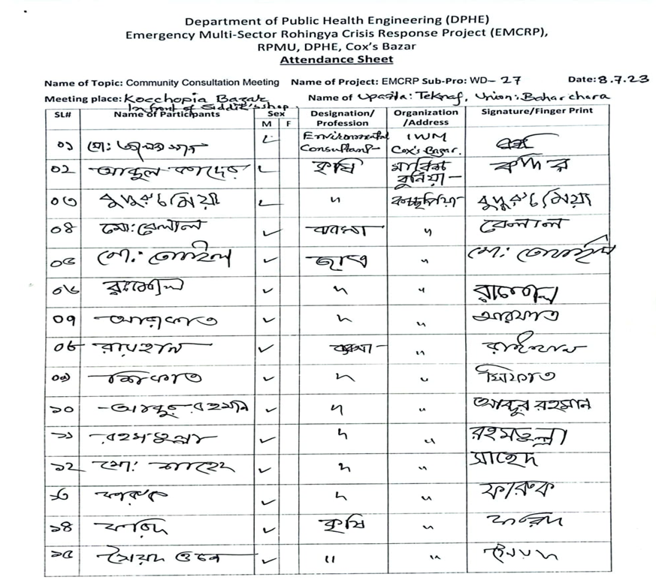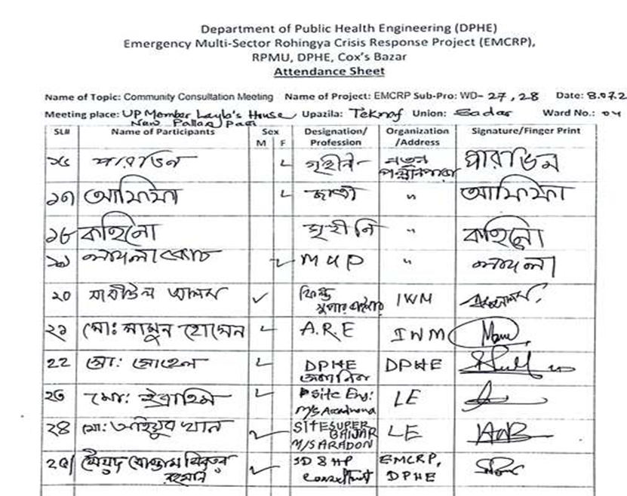

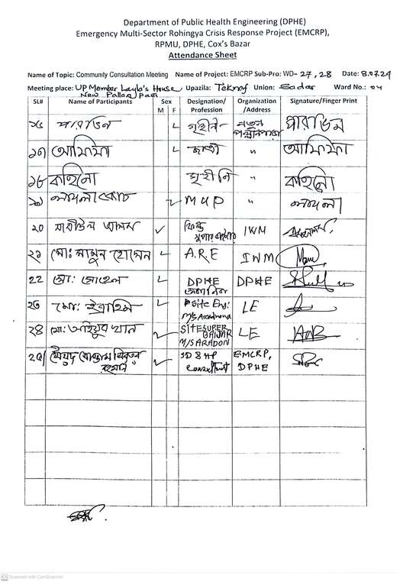

|  |
| --- |
|  |
|  |
|  |

|  |
| --- |
|  |
|  |

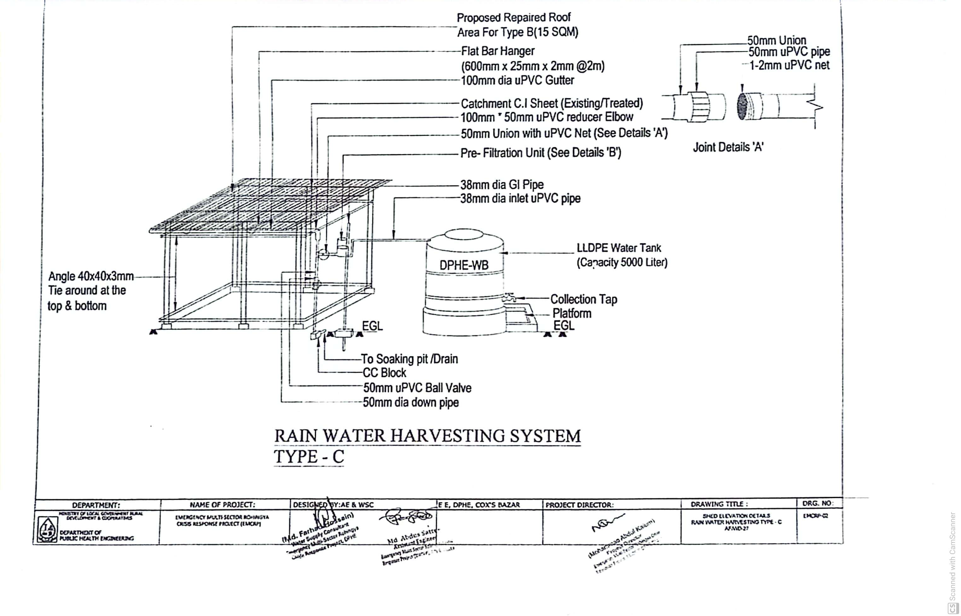

**Appendix-04: Proposed design of Rainwater Harvesting System (RWH) Type-C**

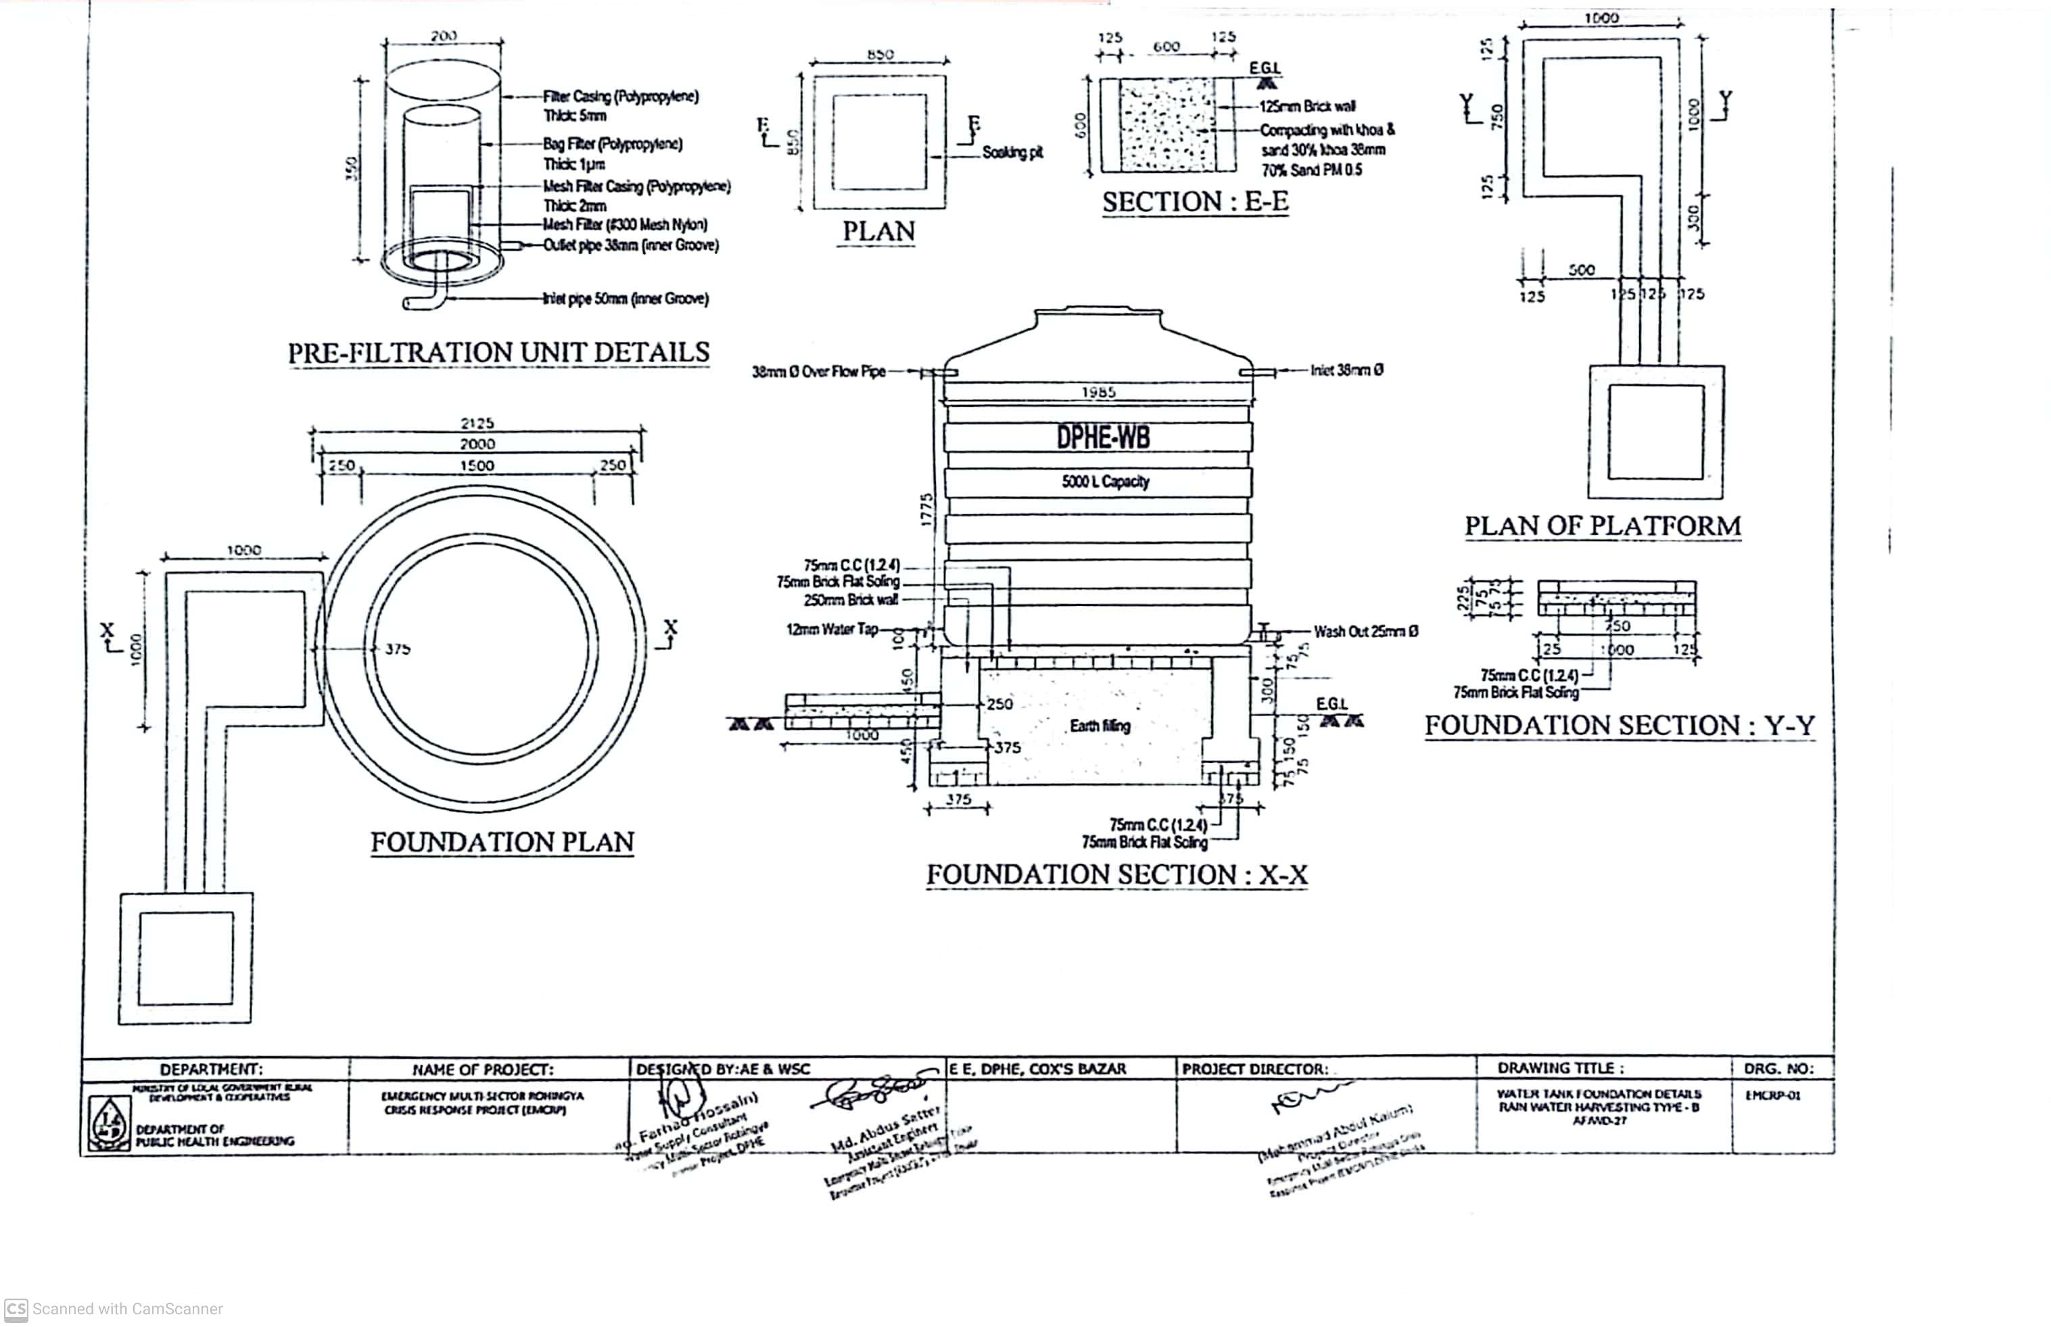

**Appendix 05: Labor's Code of Conduct (CoC):**

**Code of Conduct (CoC)**

(for Contractor)

Location:

Contracting Organization:

I am . . . . . . . . . . . . . . . . . . . undertake to abide by the following orders, instructions and prohibitions at all times while working at the site.

1. Always treat all local communities with courtesy, courtesy and respect.

2. Under no circumstances will create any kind of relationship with local women, children.

3. Will not take any kind of help or assistance from local people intentionally or unintentionally.

4. Under no circumstances shall give any assurance or undertaking to the local people.

5. Will not harm animals, plants and the environment at work.

6. Always wear and use safety clothing and equipment at work.

7. Always display and save ID Card in the work place.

8. Under no circumstances will indulge in any kind of anti-social activities and any kind of disputes with local people.

9. In case of taking any emergency decision will prior discuss with concerned officer.

If any exception to the above matters occurs or occurs, then I will be obliged to accept the legal punishment or solution taken by the administration in this regard.

…………………….

Signature and Date

**What must be kept in the project site are as follows:**

1. List of workers and officers

2. Attendance Register

3. Leave Register

4. Register for recording details of accidents

5. Register for recording complaints

6. Contract Related particulars

7. In case of emergency contact mobile numbers with names and designations of at least 2 officials shall be displayed in large letters in Bengali and English at visible place.

8. For emergency contact with nearest hospital, police station and doctor their mobile/telephone number shall be displayed at visible place in Bengali and English big letters.

9. Placement of full information and scope of work at work site shall be displayed with a banner at visible place.

10. Provision of safety signs, warning information and safety fencing shall be provided.

11. Keeping safety materials and equipment and first aid arrangements.

12. Provision of arrangement of car or motor cycle for emergency use.

13. Provision of easily identifiable signs or safety lights at work hazardous places for day and night.

(N.B. The name and location of each organization should be mentioned on the register book)

**Environmental Precautions for the work place: -**

1. No fire shall be ignited unless necessary
2. Animals should never be injured
3. Shall avoid all types of pollution
4. No tree can be cut or damaged without permission
5. Resources should be used appropriately
6. Try to use renewable resource at the best possible way
7. At the end of the work, the previous environment should be in place as much as possible.

**Report Prepared by:**

**Environmental and Social Safeguard Team, Contract Package No. AF/SD-21, IWM, EMCRP**

**(Syed Mostamsirur Rahman)**

SD & HP Consultant

RPMU, EMCRP (DPHE Part)

Email: [smrahman515@gmail.com](mailto:smrahman515@gmail.com)

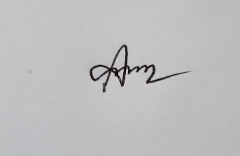

**(Mahbubul Alam)**

Environmental & Hydrogeologist Consultant

RPMU, EMCRP (DPHE Part)

Email: [alam.mahbubgeo@gmail.com](mailto:alam.mahbubgeo@gmail.com)

**Reviewed by:**



**Sarmistha Acharjee**

Deputy Project Director,

EMCRP, DPHE, Cox's Bazar

Email: coxemcrp@gmail.com



**(Md. Muktadir Harun)**

Social Development Officer,

EMCRP, DPHE, Dhaka.

Email: [mh.dphe@gmail.com](mailto:mh.dphe@gmail.com)

**Approved by:**

C:\Users\PC\Desktop\Signature 1.png

**(Mohammad Abdul Kaium)**

Project Director,

EMCRP, DPHE, Dhaka.

Email: [pddphe.emcrp@gmail.com](mailto:pddphe.emcrp@gmail.com)